Trends in Temperature and Precipitation for Counties in the Manti-La Sal National Forest
Bethany Llewellyn
Grand Canyon Trust
November 17, 2016

The Manti-La Sal National Forest is located in Carbon, Emery, Grand, San Juan, and San Pete Counties of southern and central Utah. In this arid region, drought conditions are a critical factor in ecosystem management, especially in the face of global climate change. The graphs in this document show past data and future projections for precipitation (mean daily average precipitation, figs. 1a, 2a, 3a, 4a, and 5a) and temperature (mean daily maximum temperature, figs. 1b, 2b, 3b, 4b, and 5b) in these counties, i.e., on the Manti-La Sal NF. The projections are for the years 1950 to 2100, and observed data are included for comparison from 1950 to the early 2000s. Two potential futures are shown: one in which humans continue with current emissions, shown in red, and one in which we make moderate efforts to reduce emissions, shown in blue.
The precipitation models for each county show no dramatic trends, except towards slightly more extreme conditions. However, the temperature models suggest clear trends towards an increase of mean daily maximum temperature by the end of the 21st century: by about 10 degrees F with current emissions and 4 degrees F with reduced emissions. Both the projections and observed data from 1950 through early 200s show an upward trend in mean daily maximum temperature.
Fig. 6 is a drought analysis of the Colorado Drainage Basin (which contains the Manti-La Sal National Forest) using the Palmer Drought Severity Index (PDSI) over the years 1900 to 2015. The PDSI is a model based on supply and demand of soil moisture, a result of the combined effects of temperature and precipitation. Ten of the last 15 years have had below normal soil moisture, while none has reached the threshold of even “moderately wet.”
Methods
Figures 1-5 were generated using Climate Explorer [https://toolkit.climate.gov/tools/climate-explorer], a free online tool available from National Oceanic and Atmospheric Administration. The chart is based on global climate models developed for the United Nations Intergovernmental Panel on Climate Change as part of the Coupled Model Intercomparison Project Phase 5 (CMIP5). The actual observed data displayed are from quality-checked, ground based weather stations.
Figure 6 was created by Josh O’Brien using data from http://www.cgd.ucar.edu/cas/catalog/climind/pdsi.html and the Palmer Drought Severity Index.
Results
The findings suggest that while precipitation may not be predicted to decrease dramatically in the coming years, risk of drought conditions (caused by a combination of precipitation and temperature) is increasing with higher regional temperatures.
Implications for Manti-La Sal NF plan assessment
It is critical that the impacts of increased temperature and risk of drought be assessed as cumulative on the Manti-La Sal NF with impacts of grazing, prescribed and wild fires, vegetation treatments, and recreation. Similarly, the implications for increasing temperature by burning fossil fuels extracted from Manti-La Sal NF must be assessed.
Carbon County

Precipitation | Temperature
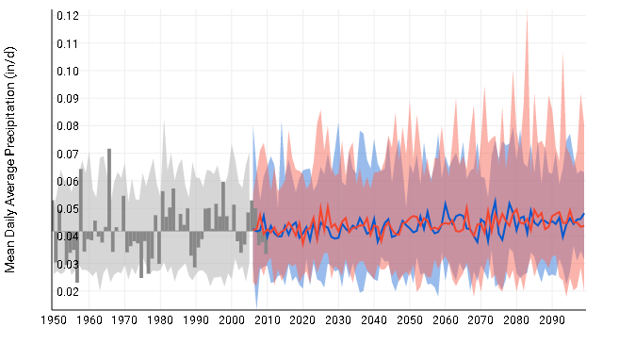  Fig. 1a. Observed and predicted precipitation for Carbon County, UT, years 1950 to 2100 | 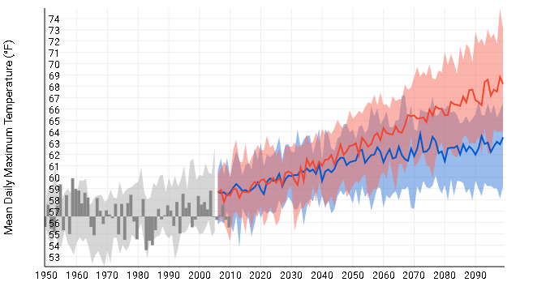  Fig. 1b. Observed and predicted temperatures for Carbon County, UT, years 1950 to 2100

Emery County

Precipitation | Temperature
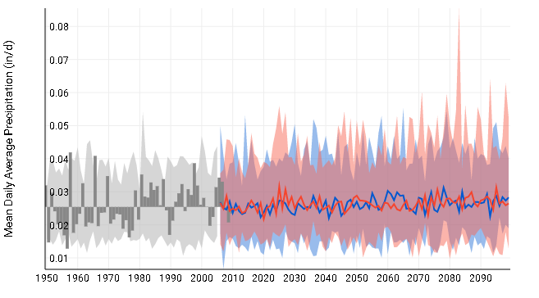  Fig. 2a. Observed and predicted precipitation for Emery County, UT, years 1950 to 2100 | 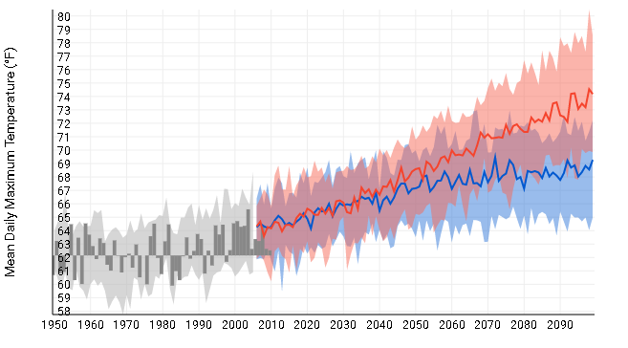  Fig. 2b.Observed and predicted temperatures for Emery County, UT, years 1950 to 2100

Grand County
Precipitation | Temperature
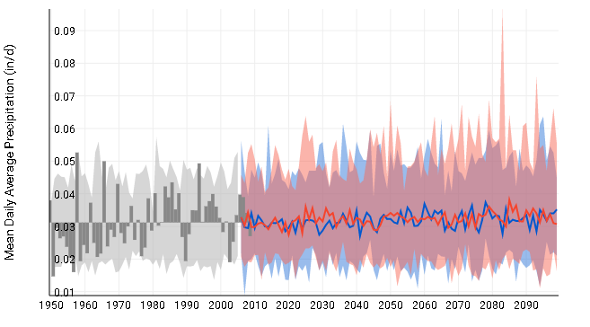  Fig. 3a. Observed and predicted precipitation for Grand County, UT, years 1950 to 2100 | 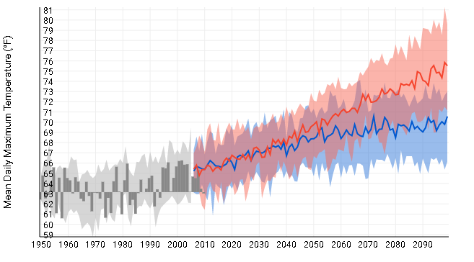  Fig. 3b. Observed and predicted temperatures for Grand County, UT, years 1950 to 2100

San Juan County

Precipitation | Temperature
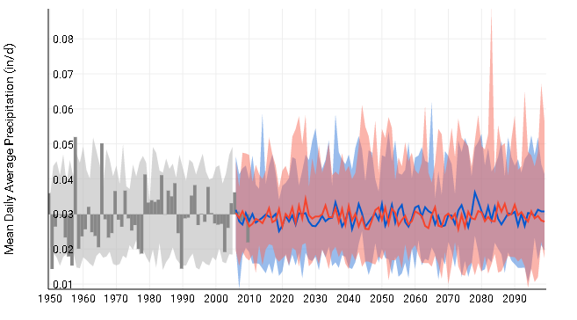  Fig. 4a. Observed and predicted precipitation for San Juan County, UT, years 1950 to 2100 | 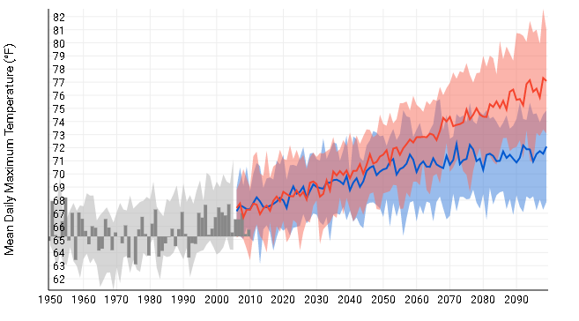  Fig. 4b. Observed and predicted temperatures for San Juan County, UT, years 1950 to 2100

San Pete County

Precipitation | Temperature
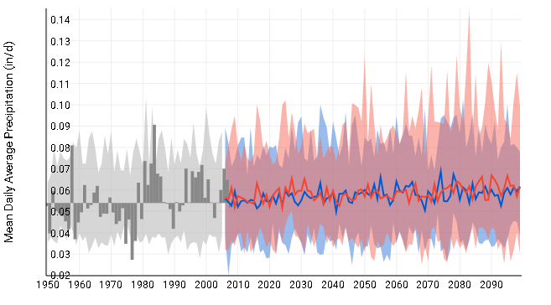  Fig. 5a- Observed and predicted precipitation for San Pete County, UT, years 1950 to 2100 | 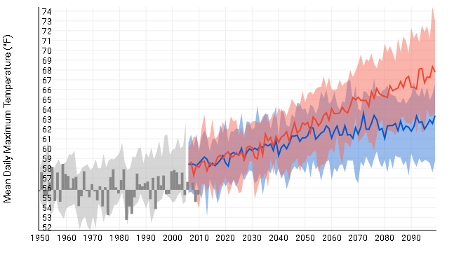  Fig. 5b- Observed and predicted temperatures for San Pete County, UT, years 1950 to 2100

Fig. 6- Palmer Drought Severity Index ratings for the Colorado Drainage Basic Climate Region, years 1900 to 2015

