Bromus inermis (Smooth Brome):
A Significant Assessment Issue
Re: Loss of biodiversity

Grand Canyon Trust

Significant Issue

Bromus inermis (smooth brome) is an exotic, rhizomatous grass that is dominating an unknown but large proportion of the Manti-La Sal NF. This is a significant assessment issue because:

- Persistent domination. Smooth brome is aggressive, generally forming largely impenetrable swards of uniform height throughout an unknown, but large, proportion of the plateaus and meadows of the Manti-La Sal NF. Aspen woodlands and mesic meadows are two of the habitats where smooth brome can be seen dominating (Smith 2016b); sagebrush is another (e.g., Figs. 7-11 below).

- Smooth brome is invasive, whether grazed or not. Smooth brome will not disappear even if livestock grazing is removed (see. e.g., the 2015-2016 study by Sue Smith of grass conditions in White Mesa Cultural and Conservation Area, which has not been grazed for the past 14 years except by trespass cattle Smith 2016a and Smith 2016b).

- Biodiversity loss. A smooth brome sward eliminates most or all biodiversity, including forbs, shrubs, and wildlife that are dependent on diverse plant species, flowers (e.g., pollinators), or openings between plants (e.g., lizards).

Combined with acres dominated by unpalatable persistent increasers [e.g., Rocky Mountain iris (Iris missouriensis), western coneflower (Rudbeckia occidentalis), false hellebore (Veratrum californicum), and cheatgrass in some areas (Bromus tectorum] as well as by increasers that would decline if grazing were removed or reduced [e.g., dandelion (Taraxacum officinale), cheatgrass in some areas] the overall picture of depleted native biodiversity is profound and not easily or ever reversed.

- Potential alteration of fire regimes. As smooth brome remains green throughout the growing season, the potential that smooth brome alters the fire regime, particularly within ponderosa pine, should be assessed by the MSLNF.

Information Provided
- Photographs (see below).
- Smith, Sue. 2016a. The invasive qualities of smooth brome. Unpublished paper submitted to the Manti-La Sal NF Forest Plan Revision Team as public input for assessment of MLSNF conditions.
- Smith, Sue. 2016b. White Mesa Cultural and Conservation Area: 2015 and2016 research. Unpublished powerpoint; data gathered for upcoming masters thesis.

Assessment Needed

Estimation is needed of MLSNF acreage that is dominated by smooth brome, combined with other seeded, non-native grasses (e.g., orchard grass (Dactylis glomerata), timothy (Phleum pratensis), and intermediate wheatgrass (Thinopyrum intermedium)). The estimation could be based on habitat types and vegetation associations (being used to estimate noxious weed infestations) combined with on-ground observations of the Forest Service,

Alternatively, the Forest could map those areas where a diversity of native grasses are known to dominate. Presumably, MLSNF field staff are acutely aware of those areas that are dominated by monocultures and near-monocultures, versus areas where native biodiversity dominates. Even a rough map of these respective areas would be helpful and could be confirmed, corrected, and refined over the years.

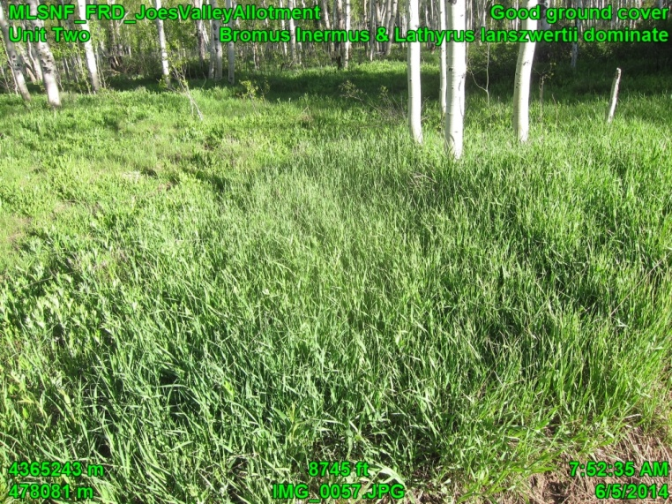  Fig. 1 Joes Valley Allotment, Ferron-Price RD | 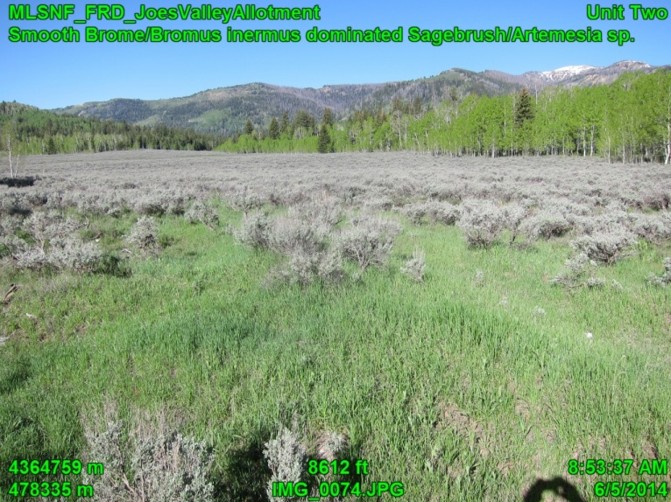  Fig. 2 Joes Valley Allotment, Ferron-Price RD

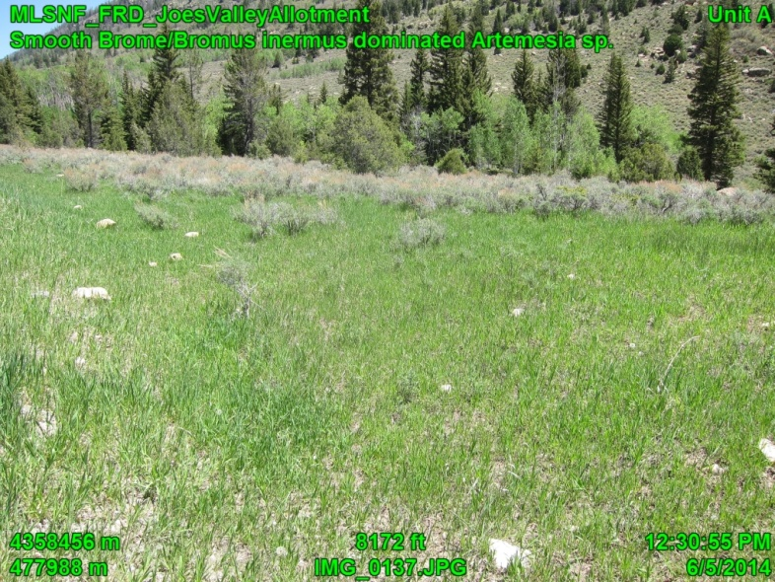  Fig. 3 Joes Valley Allotment, Ferron-Price RD | 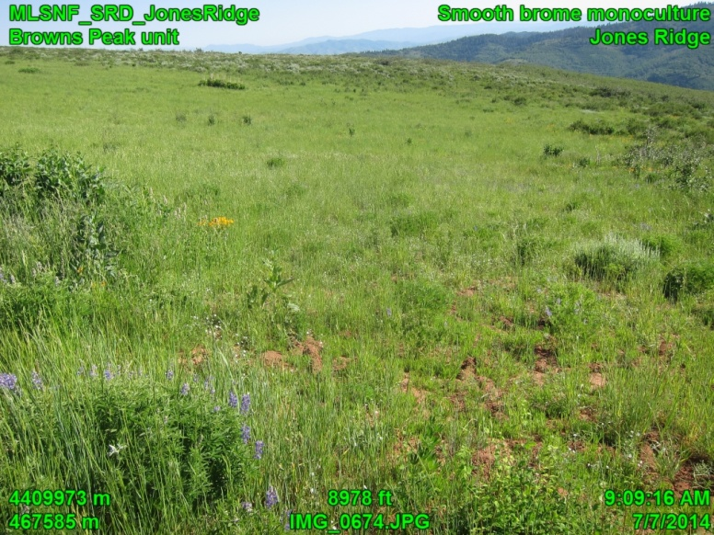  Fig. 4 Jones Ridge, Ferron-Price RD
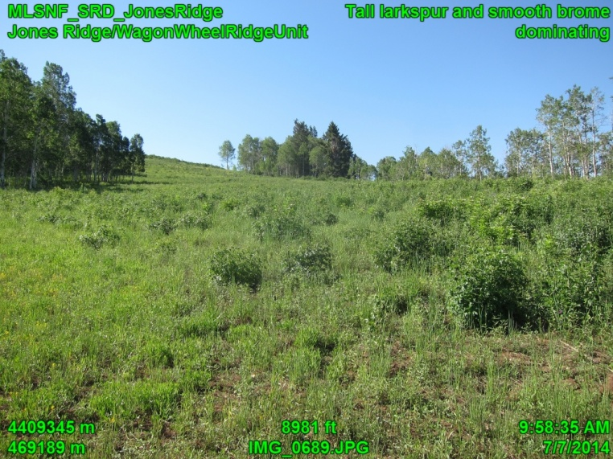  Fig. 5 Jones Ridge, Ferron-Price RD | 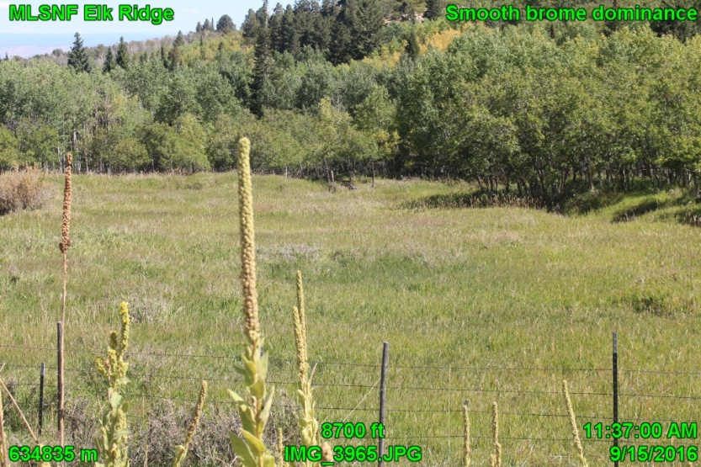  Fig. 6 Elk Ridge, Moab-Monticello RD
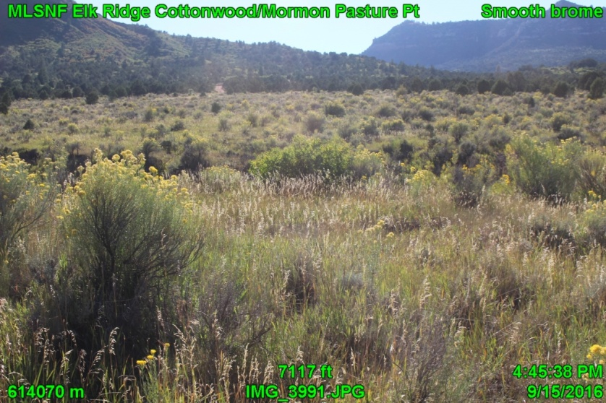  Fig. 7 Elk Ridge, Moab-Monticello RD | 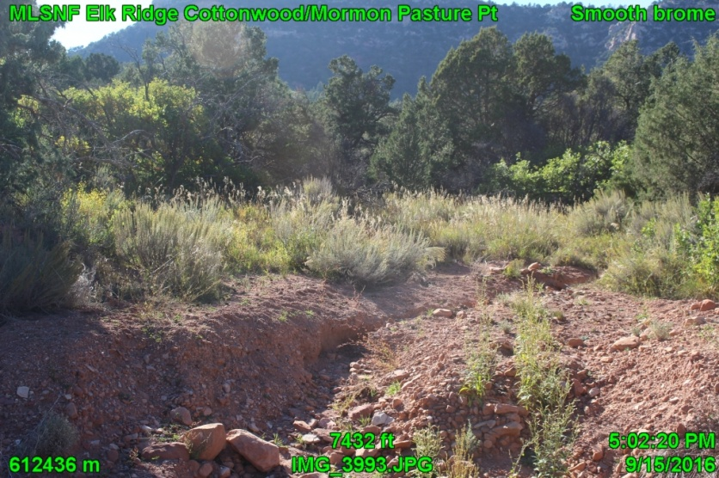  Fig. 8 Elk Ridge, Moab-Monticello RD

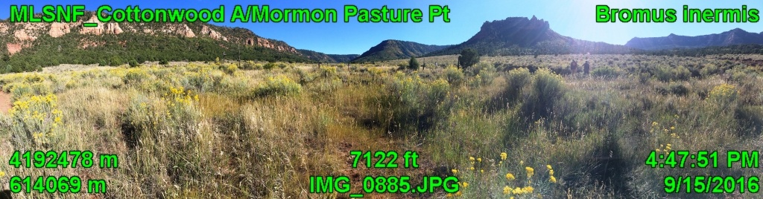
Fig. 9 Cottonwood Allotment, Moab-Monticello RD

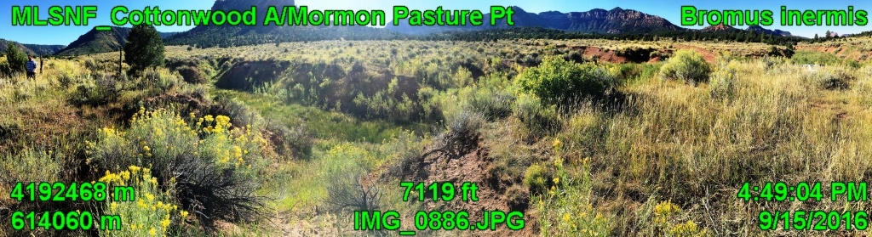
Fig. 10 Cottonwood Allotment, Moab-Monticello RD

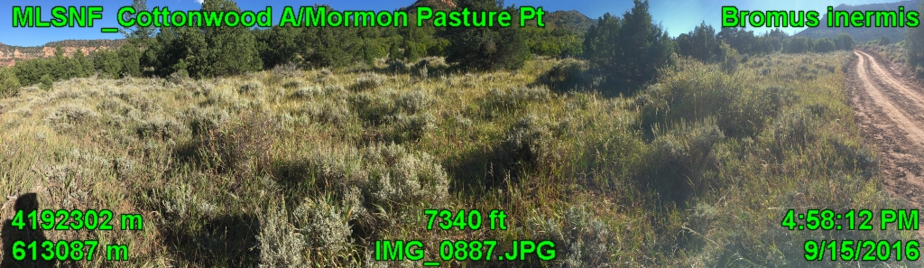
Fig. 11 Cottonwood Allotment, Moab-Monticello RD

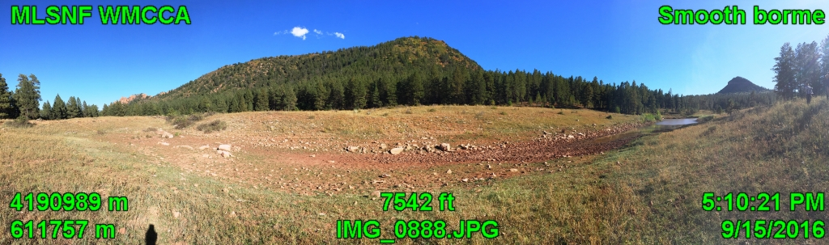
Fig. 12 White Mesa Cultural and Conservation Areas, Moab-Monticello RD
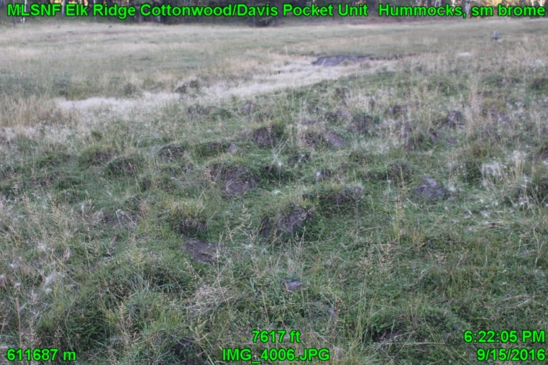  Fig. 13 Cottonwood Allotment, Moab-Monticello RD | 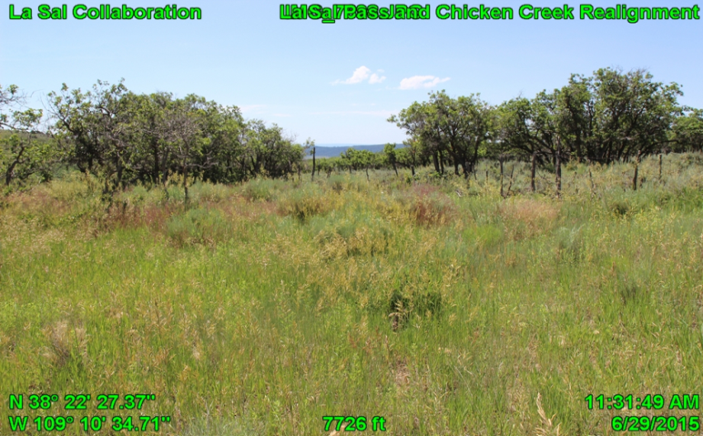  Fig. 14 Chicken Creek Allotment, Moab-Monticello RD
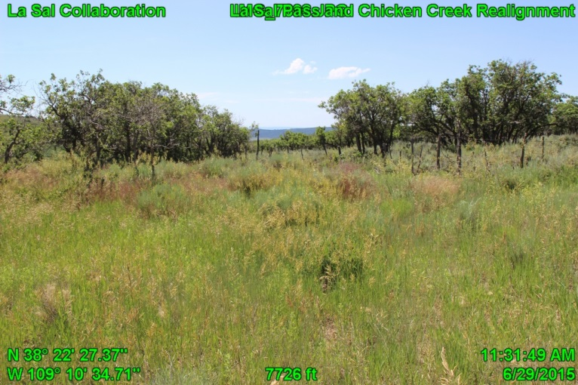  Fig. 15 Chicken Creek Allotment, Moab-Monticello RD | 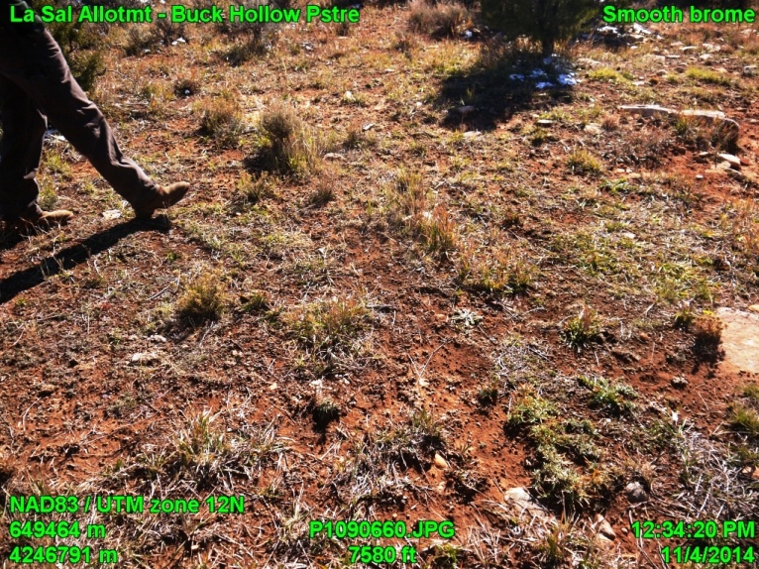  Fig. 16 La Sal Allotment, Moab-Monticello RD
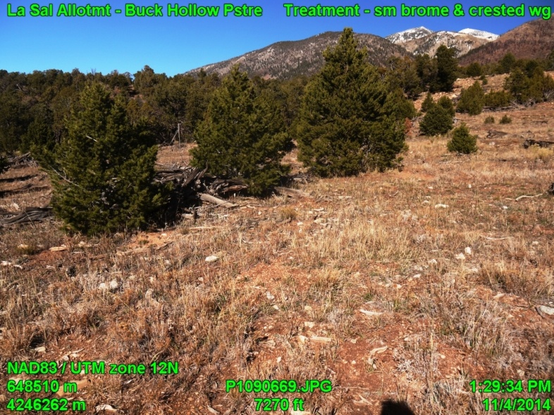  Fig. 17 La Sal Allotment, Moab-Monticello RD | 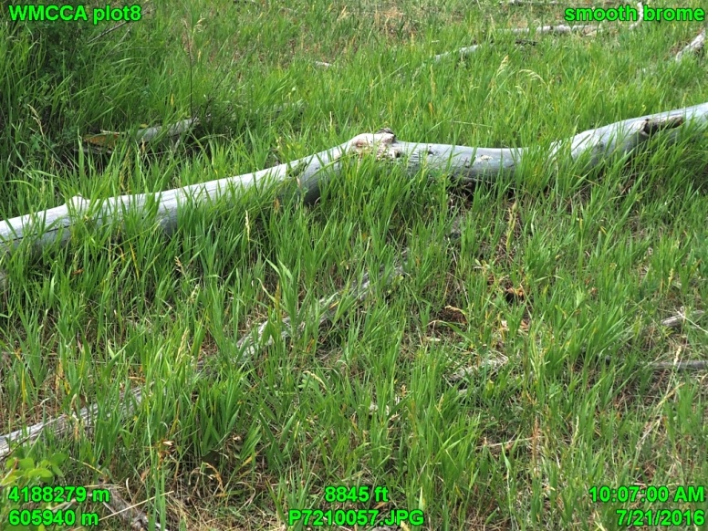  Fig. 18 White Mesa Cultural and Conservation Area, Moab-Monticello RD
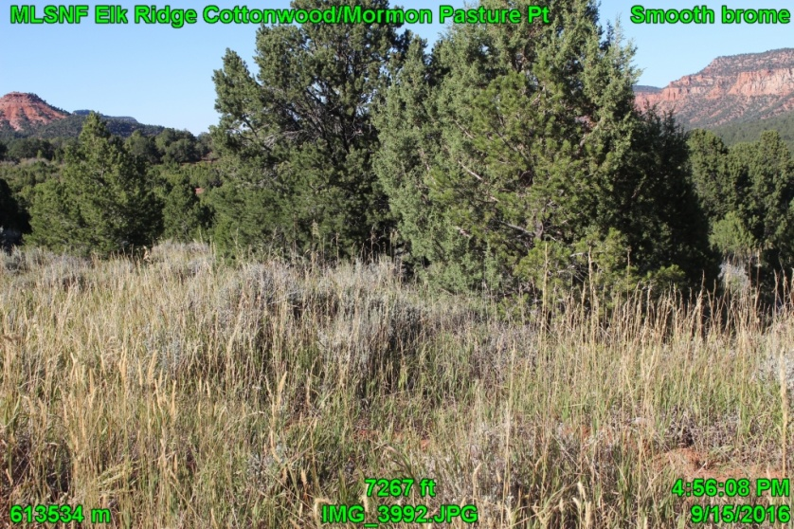  Fig. 19 Cottonwood Allotment, Moab-Monticello RD | Fig. 20 White Mesa Cultural and Conservation Area, Moab-Monticello RD

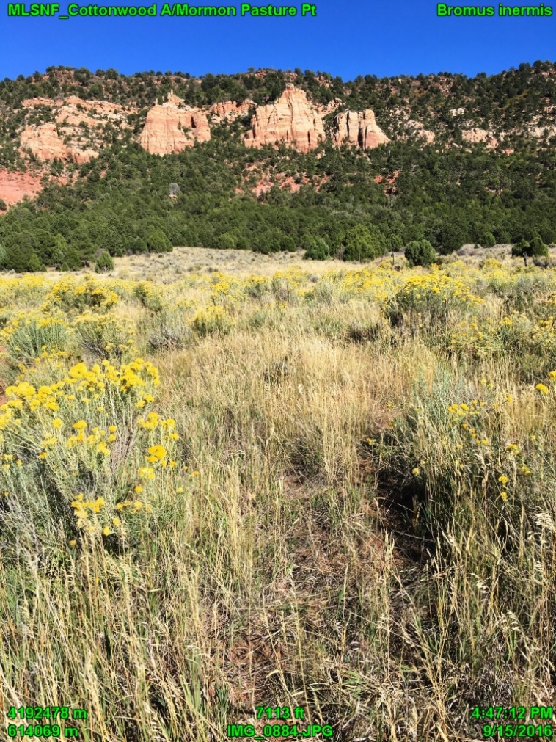  Fig. 21 Cottonwood Allotment, Moab-Monticello RD | 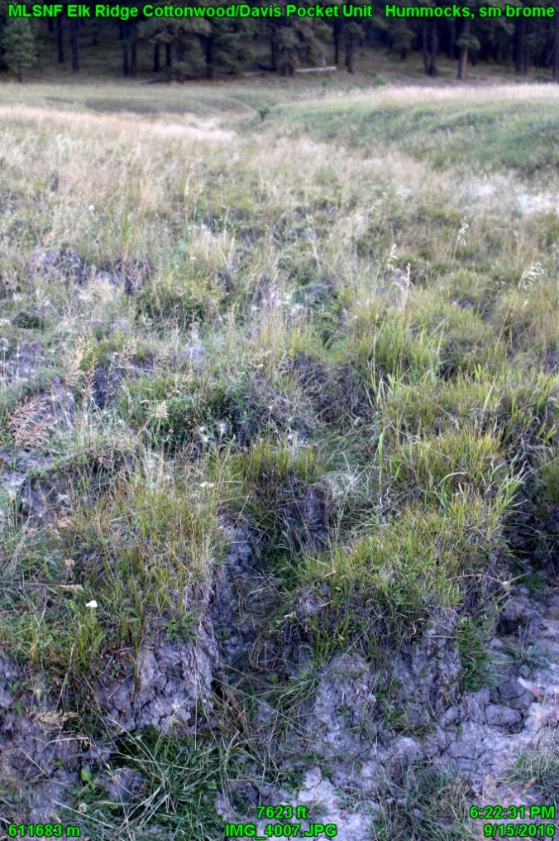  Fig. 22 Cottonwood Allotment, Moab-Monticello RD

