Joe’s Valley Spring #239 Condition Assessment
Location: Joe’s Valley Allotment, Pasture One, Manti-La Sal National Forest
Date: September 28, 2016 Begin/End Time: 2:40 to 4:00 pm
Observers: Hunter Dunn, Nina Finley, Abby Popenoe, Emma Rollins

Table of Contents
- Introduction
- Spring Evaluation Methods
- Photographs
- Assessment
- Analysis
- Recommendations

I. Introduction

Our purpose was to assess the condition of Spring 239, located on Pasture One of Joe’s Valley sheep allotment on the Manti-La Sal National Forest. The source was located at NAD 83 UTM 478195 E, 4359798 N at an elevation of 8,408 feet. It was uphill from Miller Flat Road, Indian Creek, and an impacted campground located between the road and the creek. It was downhill from an informal horse trail. This allotment was used to graze sheep from June 21st to July 15th, 2016.

The spring is located in a diverse mixed-conifer/aspen forest on a steep slope with much bare ground. The vegetation includes six conifer species, aspen, and multiple forbs and shrubs. The spring emerges from beneath the roots of a blue spruce (Picea pungens) and flowed downhill in a cold, clear stream for about 200 feet before subsiding into the ground. The spring supports four distinct microhabitats along its length: a shaded root/tree habitat at the source, an edge meadow dominated by grasses, a grove of blue spruce growing in the channel, and a terminal wet meadow dominated by sedges. The spring is important for wildlife, as shown by the flocks of red-breasted nuthatches and mountain chickadees present at the spring during the hour of our assessment. The spring also supports an aquatic community including planorbid snails, indicating its perennial flow consistency.

II. Spring Evaluation Methods:

Tools and materials used in this assessment included compass, Bushnell rangefinder, ruler, camera, and Garmin GPS unit. We divided into four roles: botanist, photographer, recorder, and illustrator, who respectively collected and preserved samples of dominant vegetation, photographed and geotagged the source and other salient water features, noted all observed plant species and wildlife signs, drafted a plan for spring restoration, and sketched a detailed map of the complex (including surroundings, distances, and dominant vegetation—Appendix A).

We assessed the flow of water at the source of each spring on a qualitative scale from 0 to 4, with 0 being dry or dewatered (no water present and likely no water for the last year), 1 dry with no water present but likely has been intermittently, 2 wet or damp soil with water likely present erratically/intermittently, 3 wet with surface water or flow present and water likely present regularly but intermittently, and 4 wet with surface water or flow present and low, moderate, or large flow likely always present.

We assessed disturbance at the site on a scale from 0-3, with 0 being no or negligible disturbance, 1 light impact but no degradation of spring site, 2 moderately impacted and somewhat degraded, and 3 highly impacted with the spring substantially degraded. Disturbances we looked for included impacts by elk, cattle, sheep, and humans.

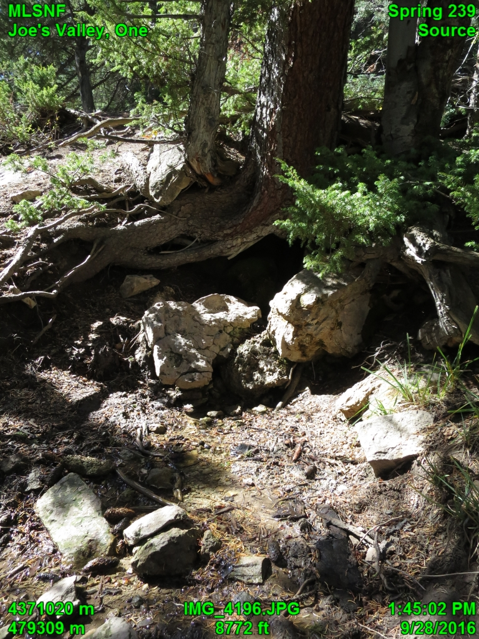
III. Photographs

Fig 1. Source of Spring 239 emerges with a constant flow rate from under the base of these blue spruce, Rocky Mountain juniper, and aspen snag.

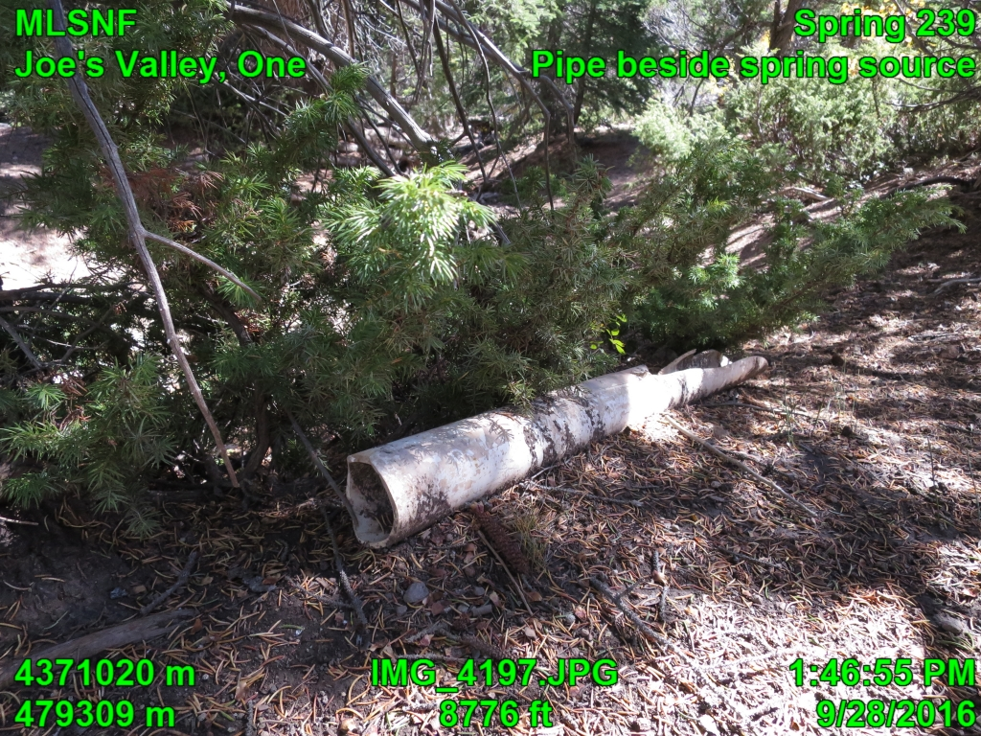

Fig 2. An abandoned pipe found on the upper bank of the spring just below the source.
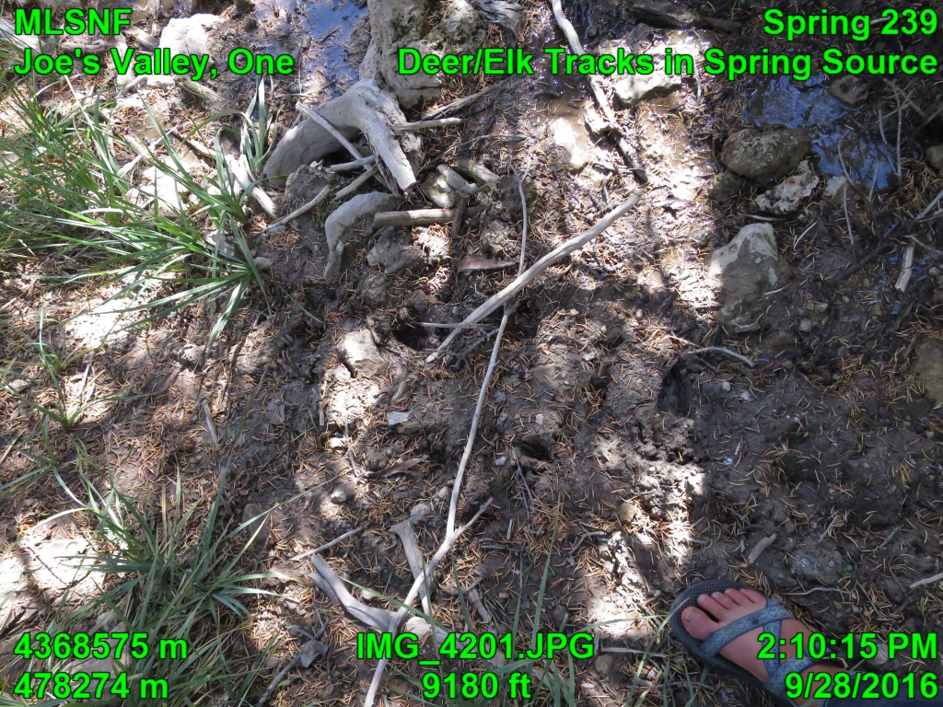

Fig 3. Deer tracks found just below the source of the spring and along the banks of the stream.

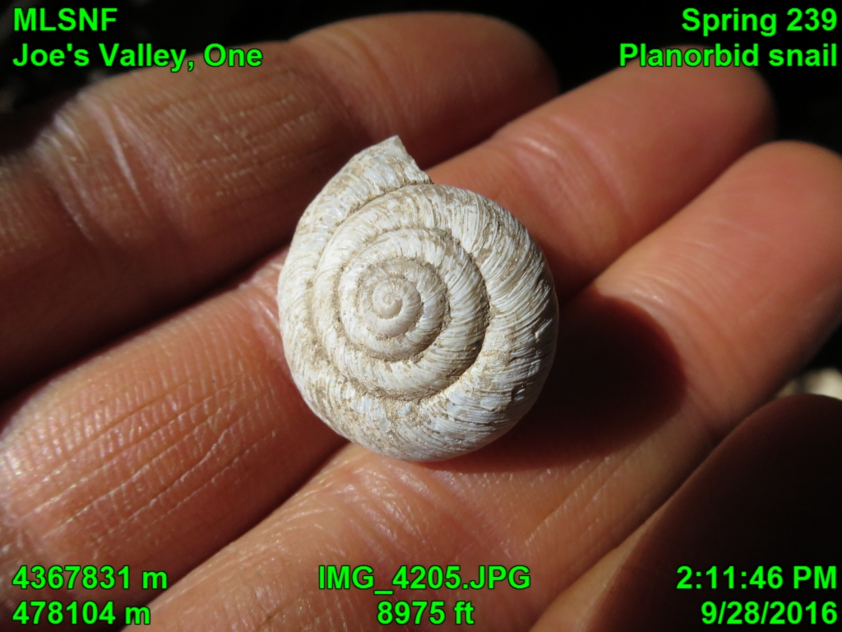

Fig 4. Planorbid snail found at the source of spring 239.

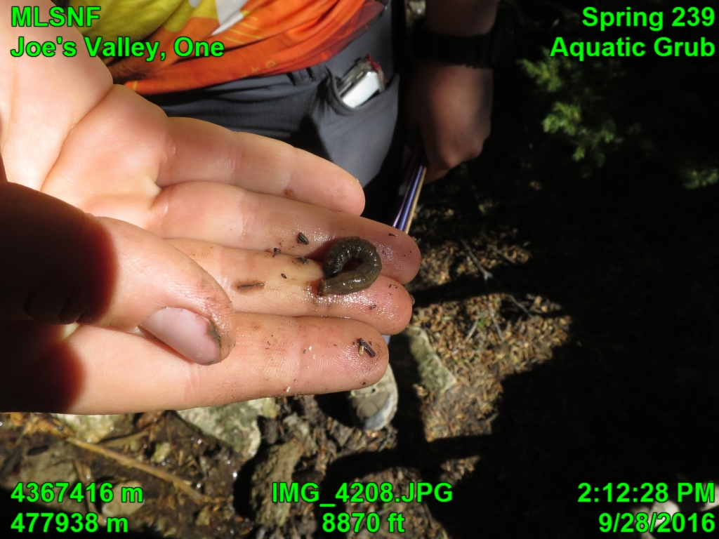

Fig 5. Aquatic grub-like insect larva found at the source of spring 239.

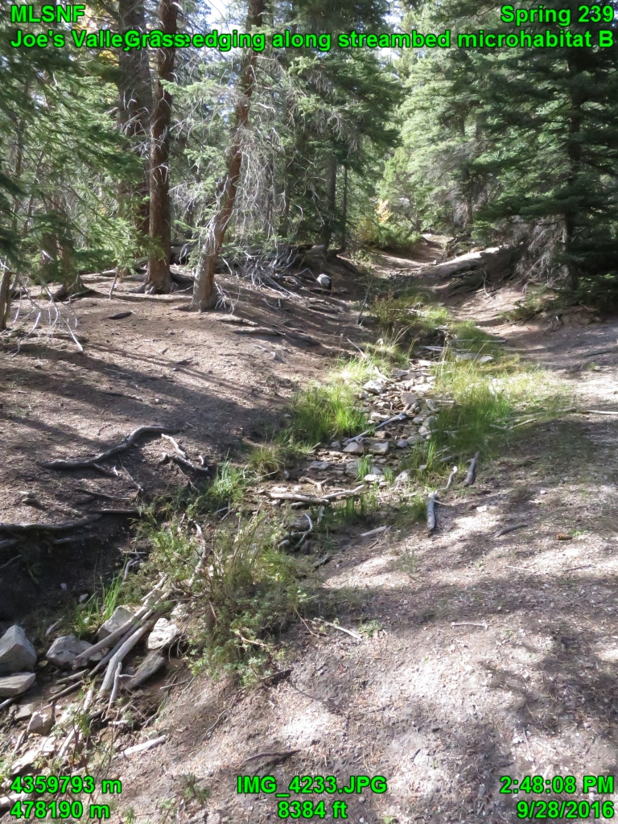

Fig 6. Microhabitat B consists of grasses, forbs sedges and rushes adjacent to the stream. Note bare dirt of the forest floor

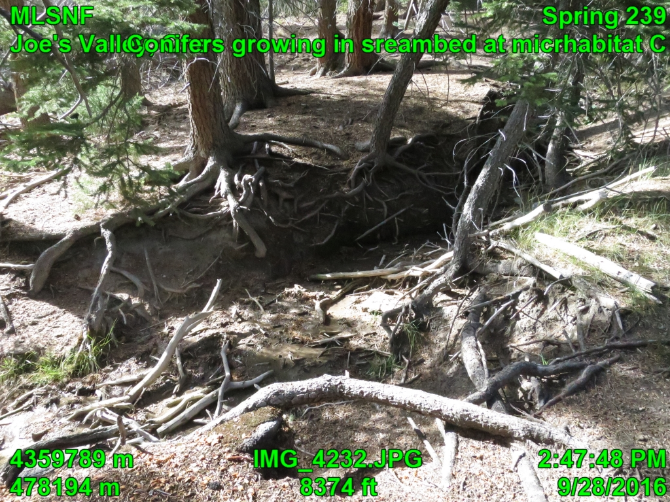

.

Fig 7. Microhabitat C included conifers, mainly blue spruce, growing within the streambed.

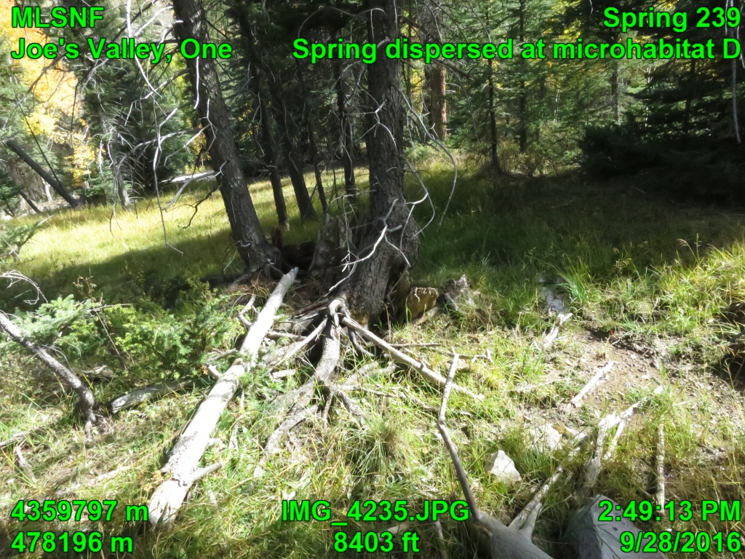

Fig 8. In Microhabitat D, the channel disperses into this open area creating a marsh.

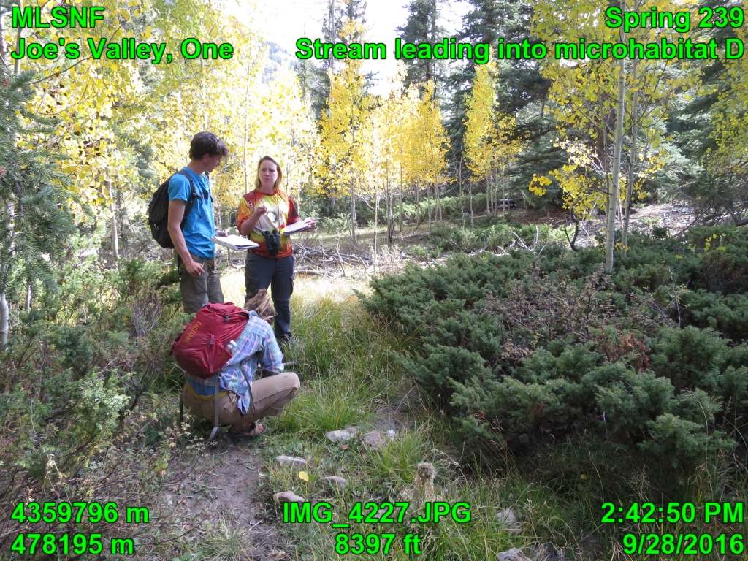

Fig 9. Entrance of stream into Microhabitat D.

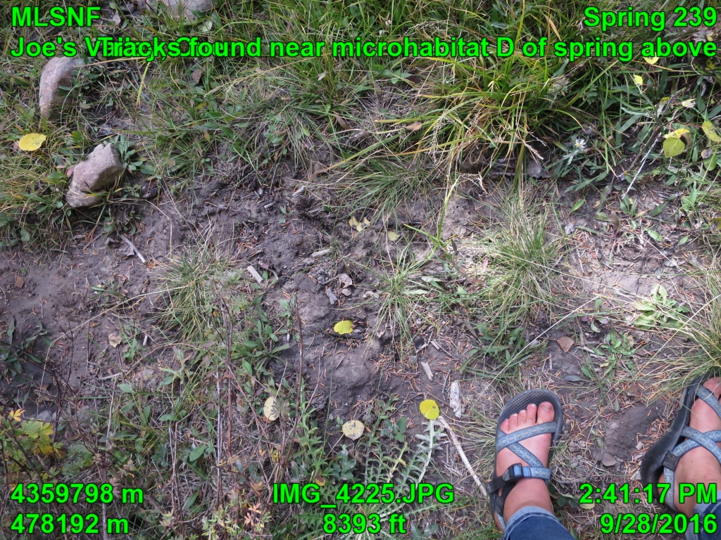

Fig 10. Deer tracks found within the damp streambed within Microhabitat D.

Assessment:

The stream flowed downhill for approximately 200 feet, during which it spanned four distinct microhabitats (map, Appendix A). The flow consistency along all four microhabitats was perennial (FC 4).

Microhabitat A: Source

The spring emerges from the ground beneath the overhanging roots of a large, healthy blue spruce through a bed of green moss (Fig. 1). Also present at the source were a dead aspen snag, Rocky Mountain juniper (Juniperus scopulorum), common juniper (Juniperus communis), Nootka rose (Rosa nootkana), Oregon grape (Mahonia repens), yarrow (Achillea millefolium), snowberry (Symphoricarpos oreophilus), shrubby cinquefoil (Dasyphora fruticosa), and grasses, including native scratchgrass (Muhlenbergia asperifolia) and bluejoint grass (Calamagrostis canadensis), and a sedge (Carex sp. Several rocks in the stream had a red lichen growing on their dry, emergent surfaces. Cold, clear water flowed from the ground into a perennial stream. The ground above and around the source was dry and firm, indicating that the water was concentrated into the stream and not diffusing to the surrounding ground. A small patch of grasses showed evidence of grazing (disturbance ranking 2, moderate impact). The only water infrastructure present was a broken, disconnected pipe to the south of the source (Fig. 2). Wildlife included two empty shells of planorbid snails (Fig. 4) and a live, grub-like insect larva (Fig. 5). Terrestrial wildlife included a flock of vocalizing mountain chickadees, a flock of four vocalizing red-breasted nuthatches, two chipmunks, and a butterfly. Tracks of elk or mule deer were observed along the banks (Fig. 3).

Microhabitat B: Edge meadow

For the first half of the slope, the stream was edged by bare dirt with signs of mild trampling and erosion. Bare dirt appeared to be a natural forest-floor condition, but it may have been exacerbated by trampling, especially on the streambanks. Approximately halfway down the slope, the banks of the stream became lush with a narrow, dry meadow dominated by two grass species and iris (Iris missouriensis) (Fig. 6). Also present were an unidentified rose and dandelion (Taraxacum officinale). A small patch of grasses showed evidence of grazing (disturbance ranking 1, light impact). A red squirrel was heard and observed.

Microhabitat C: Spruce grove

Approximately three-quarters of the way down the slope, the stream entered a small, shaded grove of blue spruce growing within the stream and on its banks (Fig. 7).Mountain phlox (Phlox austromonta) was present. At this location, the stream jogged to the south. There was no evidence of grazing. Another red squirrel was heard and observed.

Microhabitat D: Wet meadow

On the last quarter of the slope, the stream ran through a wet meadow (Figs. 8 and 9) dominated by wooly sedge (Carex pellita) and another sedge. The stream ended in a marshy patch of sedges approximately twenty feet above the road, at which point it changed from Flow Consistency 4 (perennial) to Flow Consistency 0 (dry). A small patch of swordleaf rush (Juncus ensifolius) showed evidence of grazing (disturbance ranking 1, light impact). Deer tracks were observed in the mud (Fig. 10). Also present were aspens, ponderosa pine, common juniper, snowberry, rose, yarrow, iris, dandelion, thistle, violets, and two grass species. There was also a dry wash ending in a culvert below the road. It is possible that the stream may flow through the culvert after heavy rains. Insect life included yellow-jacket wasps and grasshoppers.

Surrounding forest

Conifer species included Colorado spruce, ponderosa pine, Douglas fir, rocky mountain juniper, Utah juniper, and common juniper. Aspen were also common as mature trees, recruits, and snags. Forbs included yarrow, knickknack, thistle, purple aster, violets, and dandelion. Shrubs included rose, Oregon grape, and snowberry. Wildlife included American robins, dark-eyed juncos, Steller’s jays, and common ravens. Horse hoof-prints were observed along the trail that ran adjacent to the spring and continued above the source.

V. Analysis

Overall, the spring was in good condition. Grazing impact was minimal. The most detrimental impact was erosion along the banks due to trampling by ungulates, probably elk, deer and horses. This erosion was exposing the roots of streamside trees and contributing to bare ground. This spring appears to be of high importance to the ecosystem because it provides four distinct riparian habitats along its banks. Because the stream is very short (only 200 feet long), it is vulnerable to disruption if it were subjected to higher-impact grazing such as a longer period of use or a switch to use by cattle.

VI. Recommendations:

Fencing is a possible option here for protecting the spring and preventing erosion on the banks of the adjoining stream. However, as sheep are only present here for a short period of the year, it could also be effective to just have shepherds avoid this location with their sheep.

Appendix A: map of Joe’s Valley Spring #239
