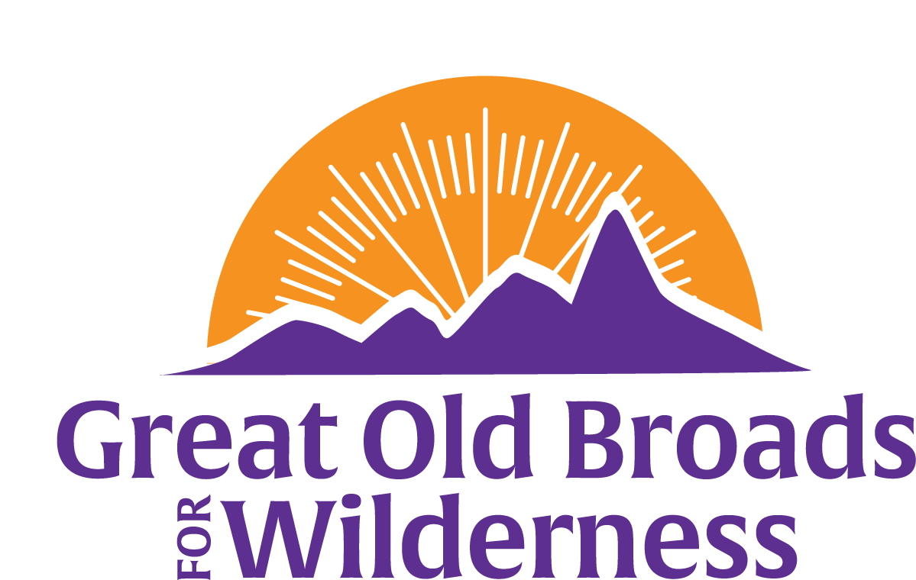
Northern Front Range Broadband News

February 21, 2025
Welcome, members and friends!  The Northern Front Range Broadband is getting together for education, advocacy, stewardship and fun!  March 3 Snowshoe hike:  Have fun in the snow: Snowshoe hike in March to either the Cameron Pass area, Colorado State Park or snowy places. And March 16! For either or both dates Please contact Natalie: econats@gmail.com or 828-899-1915 if interested and we will work out the details.  March 20 Meeting:  5:30 pm at Odell Brewing Co - 800 E Lincoln Ave  Fort Collins, CO 80524  Come hear from Tristan Kubik, speak about the wild world of insects! An entomologist, Tristan is staff with Colorado Natural Heritage Program (CNHP) at Colorado State University.  March 27 - learn how to use iNaturalist app to identify plants and record data for the Statewide Biodiversity Study. Please mark your calendars for the date and time – 3:30 to 5 pm. Zoom invitations and a location for in person learning will be sent soon. Please RSVP to Anne Anne.DalVera@gmail.com to sign up!  More information is coming! Keep us in your inbox!  Please consider contributing to Great Old Broads www.greatoldbroads.org  Become a member or renew your membership http://www.greatoldbroads.org/join-a-broadband | Calendar  March 3  Snowshoe hike  March 16  Snowshoe hike  March 20  Insect world & future activities!  March 27  iNaturalist Training  Future events:  Meetings with biodiversity speakers every other month on Third Thursdays - May 15 - Wolves of Colorado!  Questions?  Call 970-317-5410

