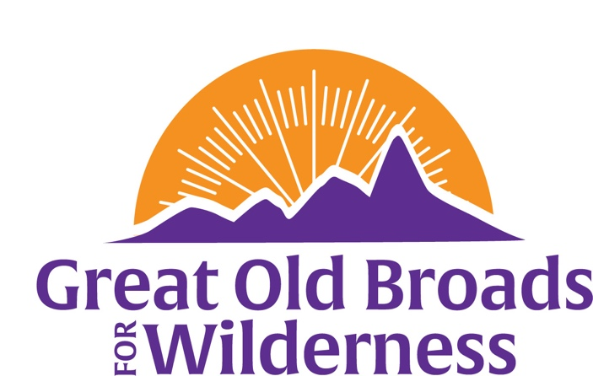

Northern Front Range Broadband News
March 13, 2025 Update
Welcome, members and friends!  The Northern Front Range Broadband is nimble and responsive to what is going on! We are getting together for education, advocacy, stewardship and fun. People are asking, “What can I do?” Answers below.  March 19 – Let’s protect NEPA – our bedrock National Environmental Policy Act protects lands and waters of the nation. National Broads webinar. Register here. See the invite attached to this email for details.  March 20 Meeting:  5:30 pm at Odell Brewing Co - 800 E Lincoln Ave  Fort Collins, CO 80524  Come hear Tristan Kubik, speak about the wild world of insects! An entomologist, Tristan is staff with Colorado Natural Heritage Program (CNHP) at Colorado State University. We will also plan future activities. RSVP – text 970-317-5410 Today!  March 27 - learn how to use iNaturalist app to identify plants and record data for the Statewide Biodiversity Study. Click on this poster for details on either an in-person or Zoom workshop. For Zoom - On the day, at 3:30 pm, click on the word ZOOM on the poster to connect to the workshop!  April 5 – Protests not your thing? You want to express your opinion to protect public lands and Wilderness? Join us to write postcards to our elected representatives thanking them or inspiring them to do the right thing. Call or text Anne for details - 970-317-5410 cell  Check out the “25 Things You Can Do” about things as they happen. It is in the upcoming Broadsides, a member newsletter relevant nationwide.  Please consider contributing to Great Old Broads www.greatoldbroads.org  Become a member or renew your membership http://www.greatoldbroads.org/join-a-broadband | Calendar  March 19  Protect NEPA  March 20  Insect world & future activities!  March 27  iNaturalist Training – gather biodiversity data!  April 5  Postcard writing to raise your voice!  Future events:  Meetings with biodiversity speakers May 22 - Wolves of Colorado!  Questions?  Call 970-317-5410

