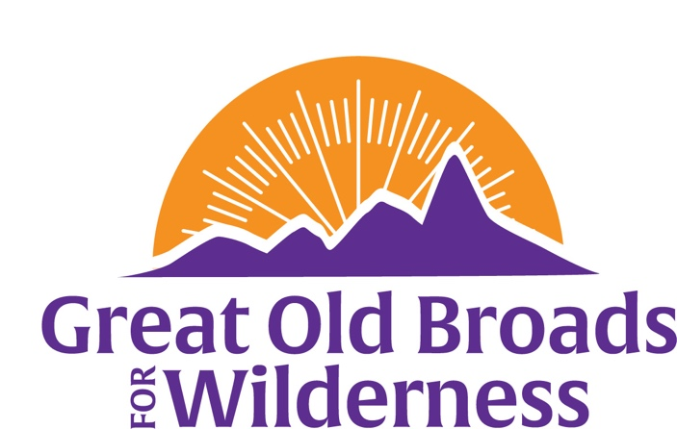

Northern Front Range Broadband News
March 30, 2025 Update
Welcome, members and friends!  The Northern Front Range Broadband has been busy! We would love to have you join us! In March we had a meeting and heard the entomologist, Tristan Kubik, speak about the vernal pools and the amazing, sometimes ancient creatures that come to life when rain fills the pools. When rain comes in April and May, we will go for a hike in the Pawnee Grasslands to document these pools. To be notified when to explore with us, call 970-317-5410.  We also met with CNHP to learn how to use iNaturalist app to identify plants and record data for the Statewide Biodiversity Study. We will learn how to access CODEX, the database of Colorado life forms on a date in April.  April 3 –Adovcate to Protect Public Lands with the Broads and beyond – online training available through Rise for Democracy. Click here for more information.  April 5 – Hands OFF! Rally in Fort Collins! Let’s speak out with signs to get the government to protect public lands, not sell or damage them! @ 11:45 pm – meet at the northwest corner of Civic Center Park, at the intersection of LaPorte and Howes.  April 18 – Gail is leading a scouting hike to a campsite at Dutch George off of Highway 14 to see if Dippers (aka Ouzel birds) are nesting there. We plan an overnight in May after the campground is open. Call 970-317-5410 to join us!  April 19 – Earth Day! It’s time to Mother Earth! Join us at our tent in Civic Center Park for fun activities for kids and grown-ups. 10 am to 5 pm. Bring your friends!  May 22 – our meeting and a talk by Becca Sue Burkhalter of Colorado Wild – “Coexist with Wolves”. Learn about the science, ecology and current events of Colorado’s wolves and how to help!  Become a Rocky Mountain Naturalist or Native Plant Master! CSU Extension has outdoor classes in these topics, and a Native Bee Watch program for your enjoyment and study!  Please consider contributing to Great Old Broads www.greatoldbroads.org  Become a member or renew your membership http://www.greatoldbroads.org/join-a-broadband | Calendar  TBD April & May:  Vernal Pool hike  Dipper chicks camping trip  CODEX training  April 5  Hands OFF Rally  April 18  Scouting for Dippers  April 19  Earth Day!  May 22 - Wolves of Colorado!  Questions?  Call 970-317-5410

