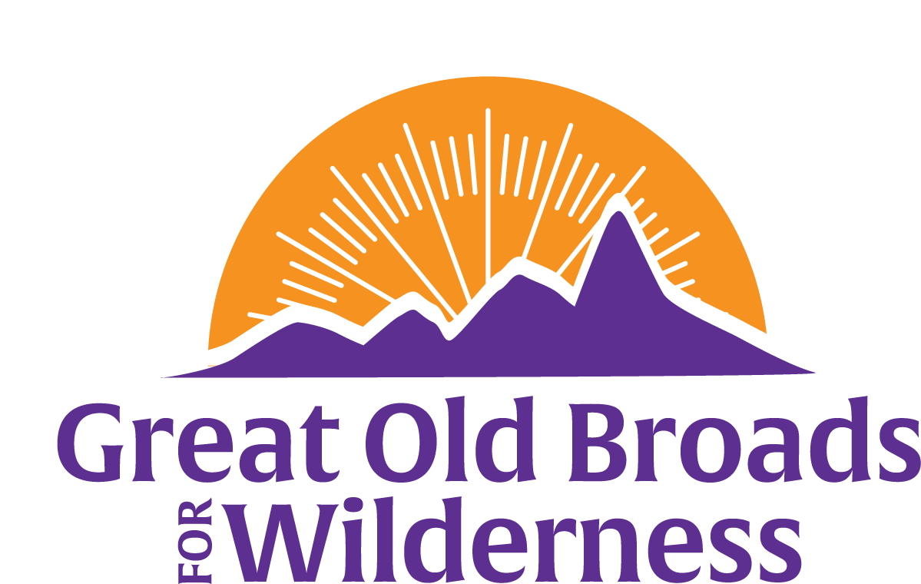
Northern Front Range Broadband News
March 4, 2025 Update
Welcome, members and friends!  The Northern Front Range Broadband is nimble and responsive to what is going on! We are getting together for education, advocacy, stewardship and fun!  March 8 International Women’s Day March – Protest & Resist! 1 pm at 6th Ave & Main St, Loveland, CO. Meet at 11:30 at Fort Collins Target parking lot, northwest corner to carpool there. RSVP to Anne 970-317-5410  March 16 Snowshoe hike:  Enjoy a peaceful snowshoe hike to Zimmerman Lake near Cameron Pass on Sunday March 16th. A moderate 1.5 miles hike, from the parking lot we'll travel among the trees to the lake with views of the surrounding mountains. There is an option to venture further around the lake. We will carpool from a TBD location, leaving Fort Collins 8:30 AM return by 4:00 PM. It's a 1/2-2 hour drive to the Zimmerman Lake parking lot. To sign up, contact Natalie: econats@gmail.com or call 828-899-1915 for details.  March 20 Meeting:  5:30 pm at Odell Brewing Co - 800 E Lincoln Ave  Fort Collins, CO 80524  Come hear Tristan Kubik, speak about the wild world of insects! An entomologist, Tristan is staff with Colorado Natural Heritage Program (CNHP) at Colorado State University.  March 27 - learn how to use iNaturalist app to identify plants and record data for the Statewide Biodiversity Study. Details in this poster for in-person or Zoom!  More information is coming! Keep us in your inbox!  Please consider contributing to Great Old Broads www.greatoldbroads.org  Become a member or renew your membership http://www.greatoldbroads.org/join-a-broadband | Calendar  March 8 International Women’s Day March for Freedom!  March 16  Snowshoe hike  March 20  Insect world & future activities!  March 27  iNaturalist Training – gather biodiversity data!  Future events:  Meetings with biodiversity speakers May 22 - Wolves of Colorado!  Questions?  Call 970-317-5410

