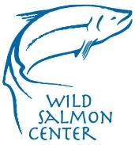
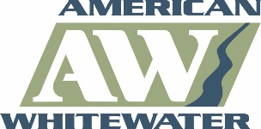
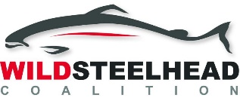
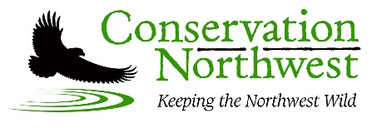
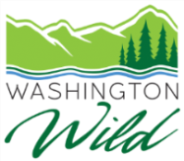
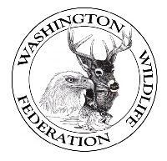
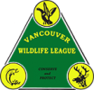
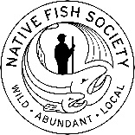

To The Chehalis Basin Board:
We, the undersigned businesses, organizations, officials, and individuals, stand with the Confederated Tribes of the Chehalis and the Quinault Indian Nation in opposition to the construction of a dam on the upper Chehalis River above the town of Pe Ell, Washington. While we empathize with basin citizens whose livelihoods and property have been impacted, the proposed dam is not a sustainable or practical solution to the devastating floods impacting communities throughout the Chehalis Basin.
Construction of the proposed dam will NOT prevent flooding, nor will it protect residents from the most devastating flood levels such as those experienced during the 2007 event. The dam would only reduce flood damage for a limited number of citizens in the basin. Residents and businesses in the lower basin, and along other flood-prone Chehalis River tributaries would not receive any benefit from the proposed dam. We cannot rationalize the expenditure of over $628 million in Washington state monies to build a 19th century solution that will not fix the 21st century flood problem that all basin residents face.
At a time when wild salmon and steelhead runs are in rapid decline across the Pacific Northwest, the Chehalis Basin remains one of Washington’s last best chances to get salmon recovery right. Construction of the proposed dam however, with its associated support infrastructure, would decimate the opportunity for salmon in the Chehalis Basin to return to their once thriving historic population levels. A few of the significant impacts the proposed dam would have on salmon include the destruction of over 12 miles of riparian habitats, elimination of critical spawning and rearing habitat for spring Chinook and steelhead, and the increase of river temperatures to near lethal levels.
The impacts are not relegated to just salmon but will also have significant impacts on wildlife species and recreationists. Wildlife impacts include chronic disturbance during the proposed 5-year construction period, loss of breeding habitat and migratory corridors and a reduction in food resources for the already endangered Southern Resident Killer Whales. Additionally, the proposed structure would eliminate 12 miles of recreational boating opportunity and significantly decrease the fishability of the Chehalis due to both a lack of access and a decline in salmon and steelhead populations identified above.
The flooding problems we face are not new. They are over one hundred years in the making. While there is not a one-size-fits all solution, there is an urgent need to act now to make changes that will set success into motion. We support implementation of a comprehensive local actions alternative that includes:
- Elevating homes, businesses, and utilities so they are above floodwater levels
- Acquiring flood-prone properties and preventing additional floodplain development.
- Allowing uninhabited areas to flood, which slows down flood waves heading for settled areas, stores groundwater for summer use, and restores soil for agriculture.
- Replacing undersized culverts to prevent water from backing up and flooding nearby homes, buildings, and towns during heavy rain events.

We do not have 10 years to wait. We need to get to work now on solutions that are proven, are a wise investment, will reduce flood damage risk now, and will help restore the Chehalis Basin for communities, fish, wildlife, and clean water.

Tom Uniack
Executive Director
Washington Wild

Jessica Helsley
Washington Program Director
Wild Salmon Center

Thomas O’Keefe, PhD
Pacific Northwest Stewardship Director
American Whitewater

Brian Stewart, M.E.S.
Cascades to Olympics Program Coordinator
Conservation Northwest

Rich Simms
Co-founder
Wild Steelhead Coalition

Charlie Clark
Director of Impact
MiiR

J. Michell Swope
Washington regional Coordinator
Native Fish Society

Amy Grondin
Manger/Member
Duna Fisheries, LLC
Port Townsend, WA

Greg Friedrichs
Owner/Operator
F/V Arminta
Port Townsend, WA

John McGlenn
President
Washington Wildlife Federation

Donna Osseward
President
Olympic Park Associates

Peter Bahls
Executive Director
Northwest Watershed Institute

Chuck Cheshire
President
Vancouver Wildlife League

