WELCOME ALL! 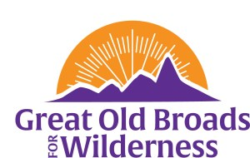

- ADVOCACY

- Protections for Eastern Oregon/SE Washington 21-inch rule reinstated Laurie
- Field Checking April 22 11:00am Laurie
- Palouse Healing Canoe Journey (5/6) and Camp Event /Khomstonik/Giving Voice (4/19) Barb
- Advocacy training with Mountaineers Carolyn
- Grizzly Bear Release into North Cascades decision in April Laurie

- STEWARDSHIP

- Solitude Monitoring June – September 2024 Laurie
- Steigerwald mulching event April 20 9am – 12pm Laurie

- EDUCATION

- Book Group: “Killers of the Flower Moon” Laurie
- Washington State Trails Conference October 3 – 5, Wenatchee Carolyn
- Salmon Super Highway Science Pub, April 22 7pm Hillsboro Downtown Station Barb
- Membership Updates Linda

- FUN

- Regional BW—Mount St Helens Carolyn
- Wilderness and Beyond Conference Oct 14-17, Estes Park, Co Laurie
- Campout Updates July 18-21, Camp Wilkerson, Or Lorena
- Joint Hikes with Willamette Broads April 24—Silver Falls State Park Laurie
- Other hikes Barb

