CASCADE VOLCANOES MEMBERSHIP MEETING AGENDA
6:30 PM Tuesday, March 19, 2024
Kennedy School 5736 NE 33rd Ave Portland
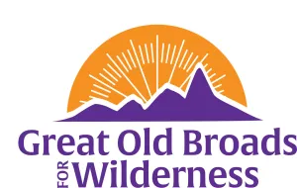

WELCOME EVERYONE! Bondi

Land Acknowledgement Barb

“Longview Biomass Plant: Green Energy or Greenwashing?”
Heidi Cody, SW WA Community Organizer, Washington Conservation Action

- ADVOCACY

HCP: Oregon Board of Forestry sign on letter Darlene

Palouse Healing Canoe Journey 4/30 - 5/9

Field Checking April 5 tentative date Jim Oliver CRF

Grazing Permit Retirement Act Campaign

- STEWARDSHIP
Stewardship opportunity Steigerwald 4/20/24 9am

- EDUCATION

WTA Symposium Oct 3 - 5 Wenatchee Carolyn

Film “Burned” Kelso Theatre Pub 3/23 2pm free

- FUN

Campout July 18 - 21 Camp Wilkerson Rosanne/Bondi

Hikes/Snowshoes

- Silver Falls Joint Hike w/ Willamette April 24
- Other Hikes first /second week of April weather TBD snowshoe Mt St Helens, June Lk/Worm Flows climbing route to tree line and or Hummuck Barb
National Broadwalks

- Wilderness and Beyond Oct 14 - 17 Bondi
- August 19-23 - Eastern Sierra National Broadwalk Bondi
Regional Broadwalk
August 7-11th- Mount. St. Helens Regional Broadwalk Carolyn

