Report of the CNHP Plant search training #2

PLEASE read through all of this email before starting!

July 16, 2025

Present:

Jess Cheadle

Jeanie Sumrall-Ajero

Anne Dal Vera

Ann Grant

Natalie Shrewsbury

Hello,

This is a summary of our meeting on July 16 with Jess Cheadle of CNHP, during which she helped us gain access to a trove of useful information and direction for searching for rare plants. I have to admit, that I was hasty in some searches, thinking that once I knew what plant to look for, I could easily go out on the ground and look. Now I feel that it is much better to be well prepared. I know that everyone is busy and wants to use their time wisely. I hope this discussion will enable us all to have forethought, and joy in our pursuit of rare plants.

Jess explained that CNHP has developed a repository for information for volunteers working on the biodiversity study with specific information about finding and documenting rare plants. It is housed on the Microsoft TEAMS platform.

To begin, you should have TEAMS app downloaded to your computer and your phone. You can start with just one of those, but each has its advantages. Next, look for an email from Jess welcoming you to the CNHP TEAMS page.

After downloading TEAMS from the App Store, we used the email that Jess sent each of us, to enter the CNHP TEAMS page. Here is what the CNHP TEAMS entry page looks like:

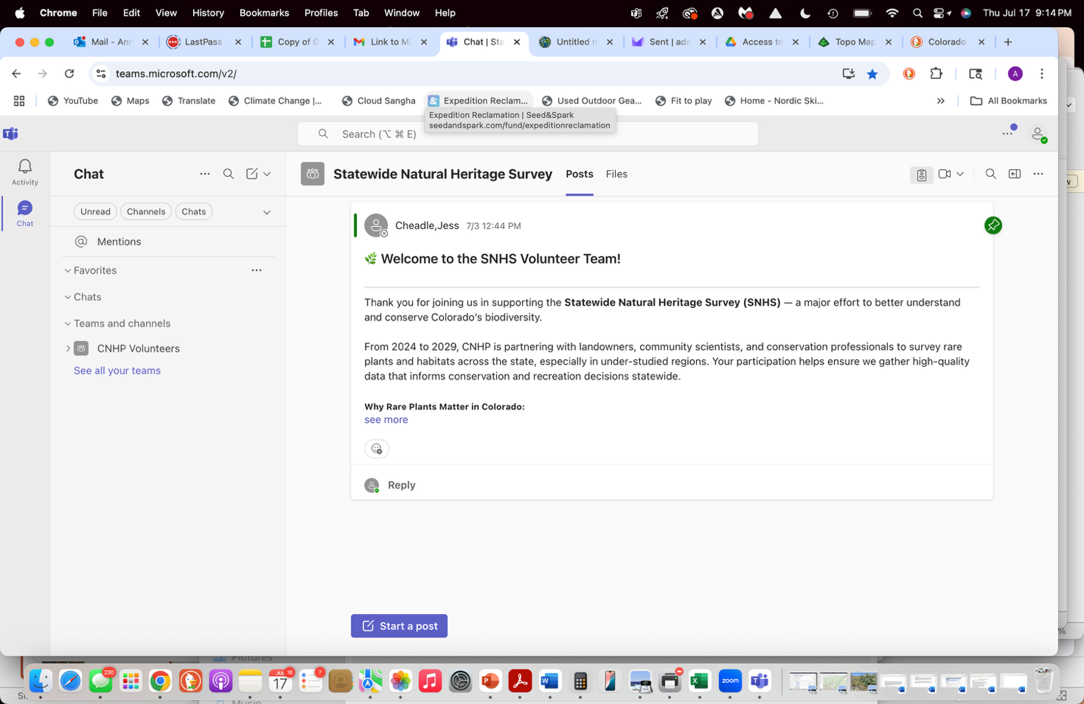

If you are trying to do this as you read, and your welcome page doesn’t look similar to the above screenshot, call Jess (208-419-9917) and she may be able to help you. I had previously used TEAMS to join a meeting, and that app doesn’t do the trick. I had to delete that version and download a different one.

On this page you see CHAT on the left side. Below that is Teams and channels. Click on it. Statewide Natural Heritage Survey will appear. Click on that. You will see the Statewide Natural Heritage Survey welcome in the center of your screen. Above that are two tabs, Posts and Files.

Click on Files. You will see 4 file folders. Inside each folder are documents with the information relevant to an aspect of plant searching and documentation. Go through all of them to read the information. Be sure to start with the START HERE folder! And go from there. Several important links are placed in the documents, and as you read along, click on them to discover more useful information or get your questions answered.

Have fun, and know that we can also talk among ourselves, using the email address

[Plant-searchers-of-the-nfr-broadband@greatoldbroads.org](mailto:Plant-searchers-of-the-nfr-broadband@greatoldbroads.org) to send and receive emails.

I hope to hear from you soon about how this is working for you!

Anne