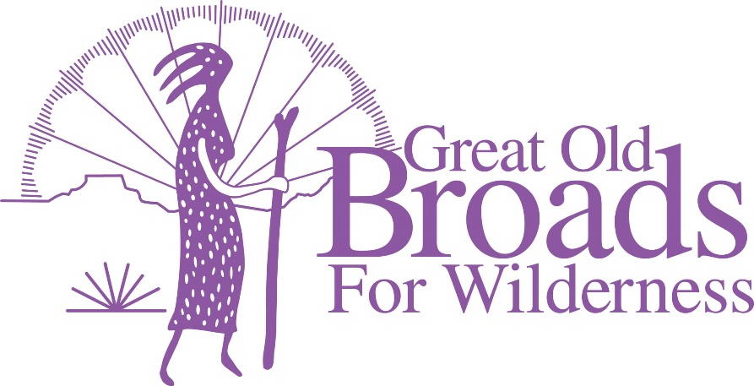
Cascade Chapter Meeting Agenda
May 17, 2022
Community Room Kennedy School McMenamins
5736 NE 33rd Ave. Portland

Eat and Socialize 5:30 – 6:30 All
6:30 WELCOME EVERYONE! Laurie

- ADVOCACY
  - Source to Sea Events
    - Portland July 10 Picnic Kelly Point Park Laurie
    - Astoria Event July 14 Micky
    - Hood River July 4 Micky
    - Rally for Salmon June 25 Willamette Park Laurie
  - Oregon Forest Issues Darlene

  - Pumice Plain Laurie

  - Timber sales on Legacy Forests in Private Lands Laurie
Center for Responsible Forestry

- STEWARDSHIP
  - Recreational Site/Solitude Monitoring Grant Laurie
In person Training June 2, 2022 ZigZag, Or
Nathaniel Brodie
Wilderness and West-Zone Trails Manager

- MEMBERSHIP updates Linda
b. Tabling Committee

- EDUCATION

- FUNDRAISING
  - Portland Century Ride/Oregon Bike June 19 (Troutdale)
  - Harvest Century Ride Sept 25 Forest Grove Laurie

- FUN
  - Rendezvous Travel and updates Laurie
  - Steigerwald NWR Hike May 22 2:30pm Laurie
  - Campout Micky
  - July 10 picnic on the Columbia River Laurie
  - 2023 Grand Coulee Dam Area Broadwalk 2023 Micky
    - Speakers
    - Stewardship
    - Food
    - Hikes

