Cascade Volcanoes Broadband Chapter Meeting
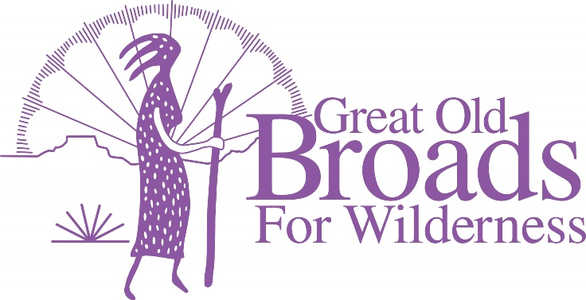
January 18, 2022
7:00 PST

Join Zoom Meeting
https://us02web.zoom.us/j/88626159516

Welcome and Happy New Year! Barb
Cascade Broads New Years Resolutions for 2022! ALL
“Bear Ears Stewardship Adventure” Sarah Madsen

ADVOCACY
- Pumice Plain Susan
- LSRD Micky
- Oregon Forest Issues Felice
- Mexican Gray Wolf Presentation and Comment Writing Jan 19 Barb
- Tongass National Forest Barb

V. STEWARDSHIP

- Tree Planting with LCEP Steigerwald Feb 5 Laurie
- Solitude Monitoring Laurie/Kathleen
- TKO Trail Monitoring Barb/Kathleen
- Field Checking Laurie
- Climate Watch Citizen Science Project (NEW!!) Laurie
VI. EDUCATION
- Book Group “Mother Tree” Barb
- “Volcanoes of the PNW” Carolyn Mastin rescheduled Feb 15 Laurie
- Equity and Justice Movie Night “Warrior Women” Feb 9 Barb
VII. FUN
- Hikes/Snowshoe Barb
- Campout/Retreat Centers Micky
- Broadwalks Micky
- Other?????

****************************************************************************************************

