CASCADE VOLCANOES CHAPTER MEETING

September 21, 2021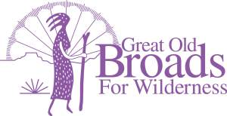
Kennedy School, McMennimans
5736 NE 33rd Ave, Portland

5:45- 6:30 Eat and Socialize (purchase or BYO food; (alcohol must be
purchased on site)
6:30 Welcome and Introductions

6:45 Presentation “Becoming Effective Allies with the Latinex Community”
- Diana Perez, Interim Chair, Southwest WA Equity Coalition, former USFS biologist and Vancouver City Council candidate and
- Ed Gonzales, President SW Washington LULAC, League of United Latin American Citizens

7:20 ADVOCACY
a. Pumice Plain Laurie
b. Hantwick Trail Laurie
d. Beavers. Eena Festival; Wisdom of the Elders Darlene
f. Wild Olympics Campaign Darlene
Letter to Wyden/Merkley Darlene
g. Western OR Forest Management Plan goals Darlene
h. Chehalis Laurie
i. LSRD signs Laurie
STEWARDSHIP
- Solitude Monitoring Laurie
- Columbia Land Trust Sarah/Barb
- Field Checking Laurie
EDUCATION
- Book Group “Caste” Linda
- Equity and Justice Linda
- 2021 Virtual National Wilderness Workshop Nov 15-19 Laurie
FUN
- Hikes: Pumice Plain hike week of 10/4 - 10/810-13 miles RT
with 1800ft elevation gain. Barb

**************************************************************************************

