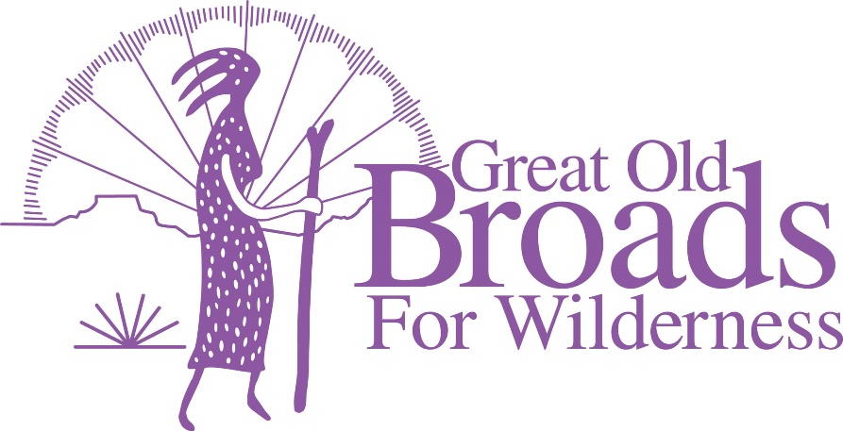
Cascade Volcanoes Leadership Agenda
April 19, 2022
- WELCOME EVERYONE! All

- ADVOCACY
  - Earth Day April 22 Noon – 2pm Vancouver Waterfront Micky
Do we need tables, signs, postcards?
  - Source to Sea Event
    - Portland July 9 or 10
Patagonia event? Micky/Laurie
    - Astoria Event July 14 Micky
    - Hood River July 4 Micky
  - Oregon Forest Issues Darlene/Felice
OR Western State Forests Habitat Conservation Plan—
Comments on Environmental Impact Statement by May 17
Darlene
  - Clark County Advocacy Night April 25 6:30 Laurie
  - Federal and Washington State Carbon Offset Laurie
    - Hike to old growth and document trees on public lands
  - Timber sales on Legacy Forests in Private Lands Laurie
Center for Responsible Forestry

- STEWARDSHIP
  - PNW Invasive Plant Council Trainings in May Laurie
  - TKO Wilderness Trail Stewards Training Barb
May 15, Sandy, Or
  - Recreational Site/Solitude Monitoring Grant Laurie
In person Training May 14 ZigZag, Or

- MEMBERSHIP updates Linda
b. Tabling Committee Laurie

- EDUCATION
  - Equity and Justice “Necessity” Film Barb
  - Wilderness Defense Webinar April 21 Parts I and II Micky

- FUNDRAISING
  - Portland Century Ride/Oregon Bike June 19 (Troutdale)
  - Harvest Century Ride Sept 25 Forest Grove Laurie
  - Broads Auction Micky

- FUN
  - Hikes Barb
  - Campout Micky
  - July 10 picnic on the Columbia River Laurie
  - 2023 Grand Coulee Dam Area Broadwalk 2023 Micky
