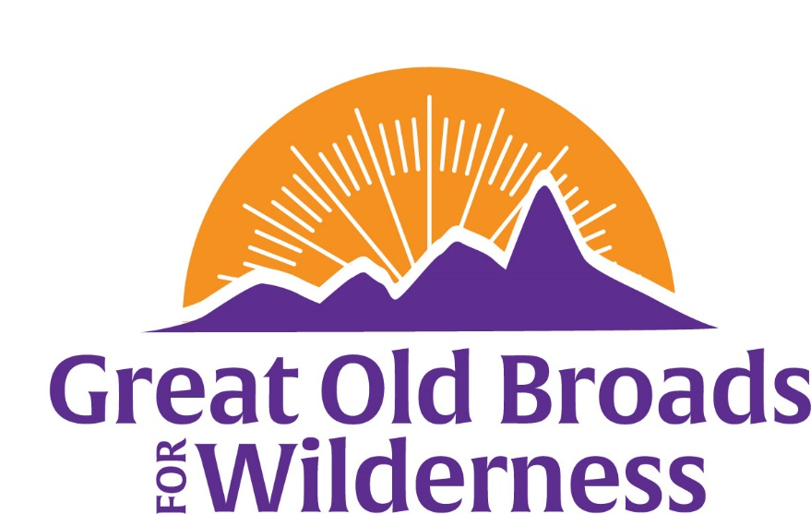

Cascade Volcanoes Membership Meeting Agenda
January 17, 2023 6:30pm
Community Room McMenamins
5736 NE 33rd Ave, Portland
I. Welcome All Laurie

- Advocacy
  - Elliot Forest Letter from CV and WV Broads Darlene
  - LSRD Feb 7 TU Legislative Day Olympia Laurie/Micky
  - Hantwick Transfer Land Trust updates Laurie
  - Spirit Lake update Laurie
  - Chehalis Laurie
  - Forest Brat updates Darlene
  - Town Hall Meetings Jan 18, Jan 20 Micky

- Education
  - Equity and Justice Museum Outing Jan 25 Barb
  - BANFF Film Festival Kiggins Thtr Feb 2 - 5 Laurie

  - WALTZ Training March 27-31 Micky
  - Public Interest Environmental Law Conf Mar 2-5 Micky
Eugene, Or (Free) Register by 1/20/23
  - Book Group “Tree Thieves” Feb 17, 2 – 4pm Laurie
  - Trout Unlimited

- Stewardship
  - WTA Trail Work Barb
  - Stewardship with SUWA late April/Sept Laurie

- Fun
  - Campout Committee Meeting 7pm Jan 18 on Zoom Laurie
  - Regional Dry Falls BW April 13 - 17 Micky/Laurie
  - Snowshoe Hike Twin Lakes 1/31 Barb
  - National Broadwalk California in May Micky
  - National Broadwalk Camp Hale, Co in Oct Micky
  - Wild for Wilderness online Auction April 14 – 23 Laurie

