Medford District, Bureau of Land Management, Oregon
Integrated Vegetation Management Project:
Penn Butte and Late Mungers Timber Sales

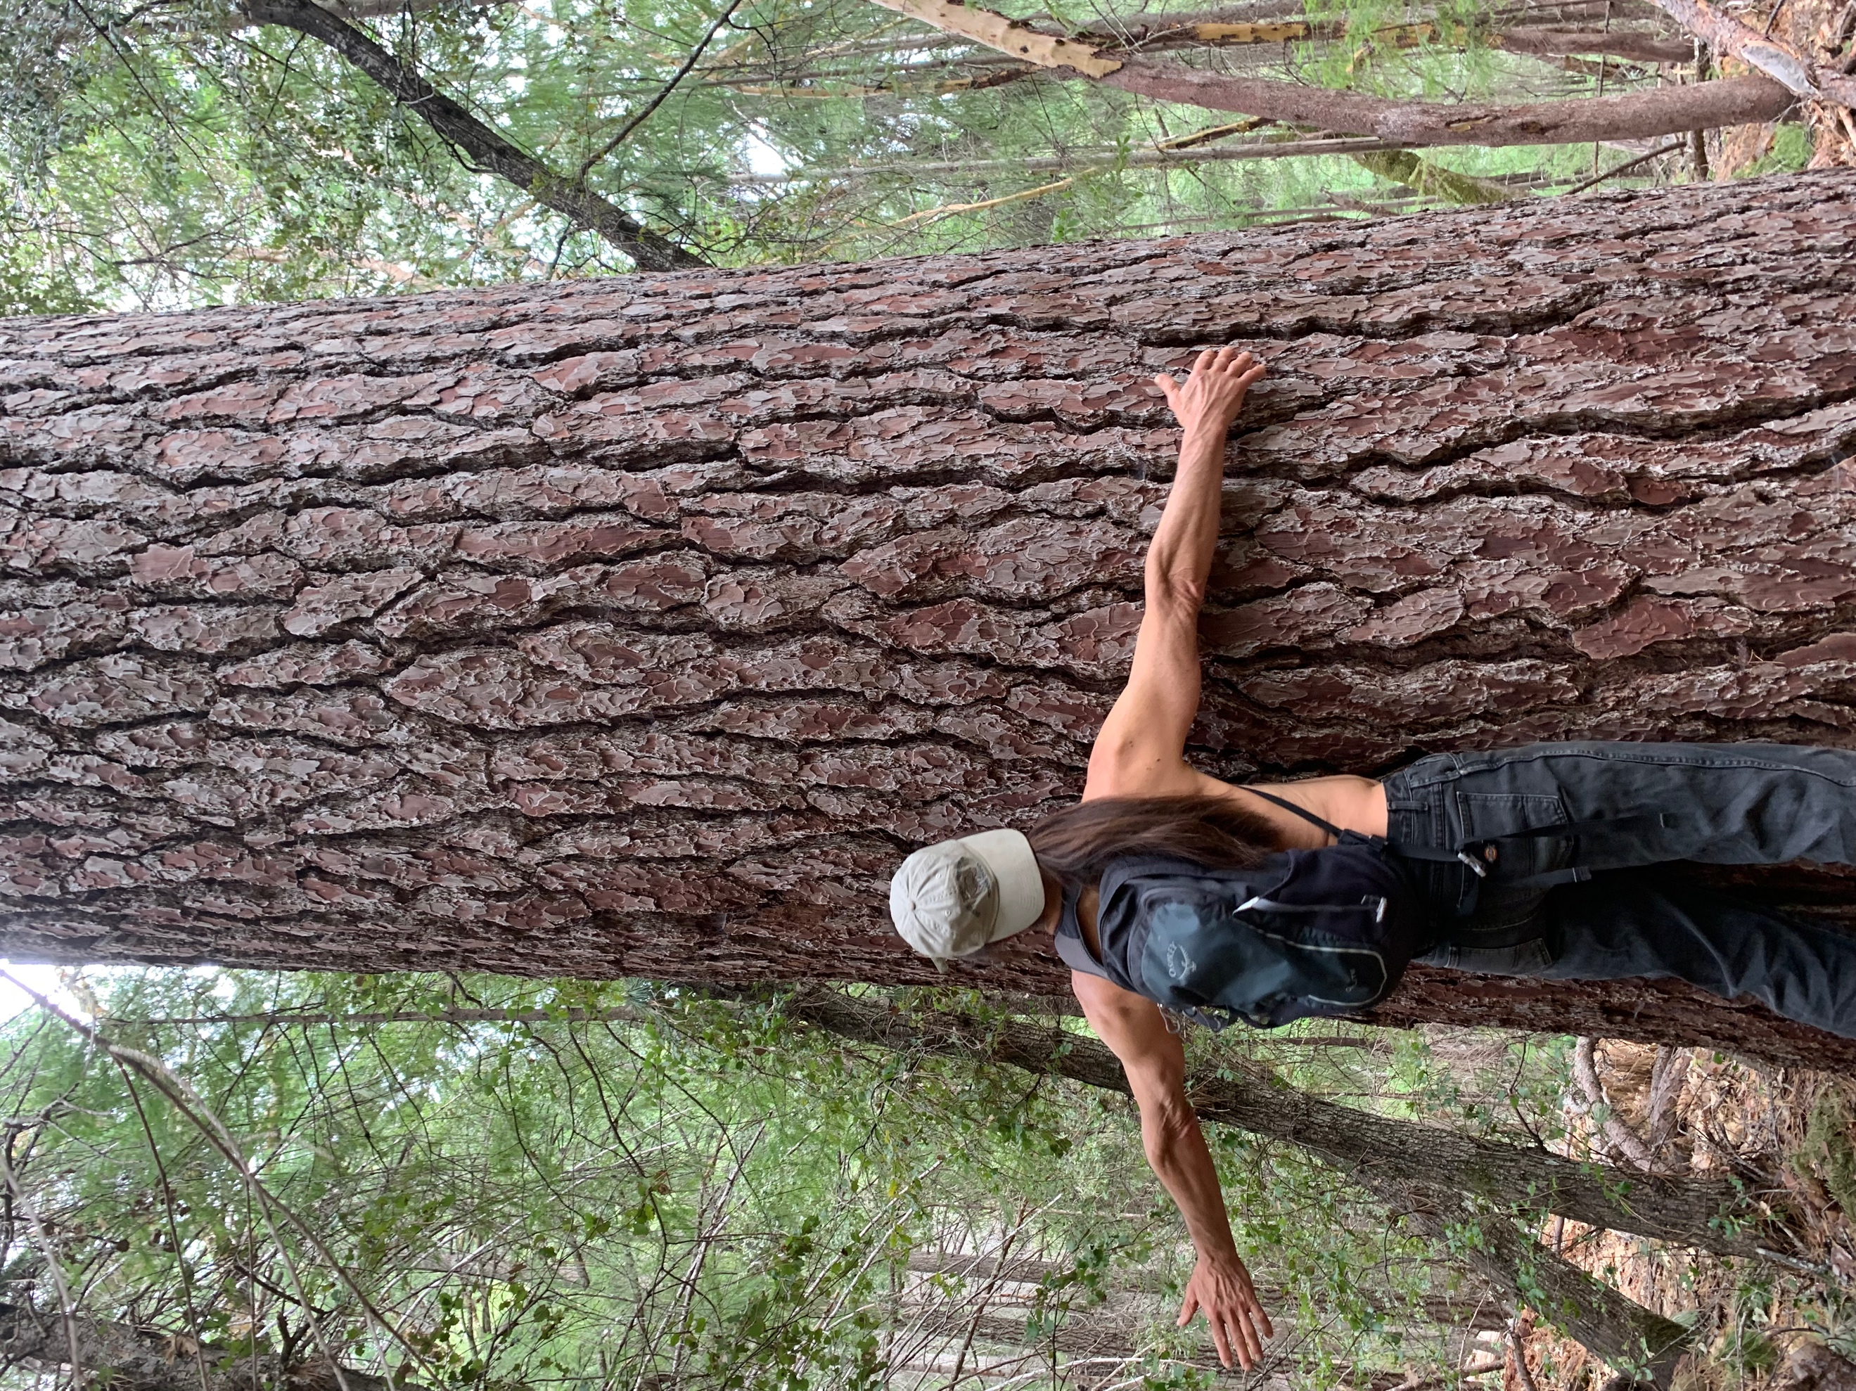
Caption: ???? Photo Credit: ???

Why this forest is special
This area is part of a 24-million acre landscape within the range of the endangered northern spotted owl and other imperiled species. The Cascade Mountain Range holds some of the most spectacular temperate mature and old-growth forests in the U.S, stretching from British Columbia to Northern California. Though heavily logged, tens of thousands of acres of towering giant trees remain alongside rushing rivers cut deep into the mountains that support wild salmon and steelhead. The BLM Medford District encompasses the Oregon portions of Southern Cascades and the Klamath Mountains ecosystems to the west. The Klamath Mountains have been called the “Galapagos of North America” and are considered by the International Union for the Conservation of Nature to be of “global botanical significance.”

Integrated Restoration Management Project (IVM)
The IVM “project area” covers the entire BLM Medford District, equivalent in size to a National Forest and encompassing 800,000 acres of public forests. IVM would commercially log up to 20,000 acres of late successional reserves, taking trees up to 36-inches in diameter-at-breast-height and over 150 years old while building up to 90 miles of new roads. Implausibly, the BLM claims a decade of clearcutting and aggressive logging of mature and old-growth forest will have no significant environmental impact.

Carbon and Biodiversity
The BLM claims that carbon emissions from logging very large old trees will reduce carbon stocks, but would be replenished overtime. They also state that “carbon emissions would be negligible and that “existing science is unable to identify a specific source of greenhouse gas emissions or sequestration as the cause of specific climate impacts at a specific location, therefore, “the appropriate context for greenhouse gas impacts is the global, regional, and continental scale”. In fact, science is able to identify sources of greenhouse gas emissions, including from logging, and the climate crisis is the cumulative result of numerous individual actions such as IVM as most of the carbon stored in old trees is released upon logging, transport and manufacture. The project area includes habitat for several endangered species that depend on multi-layered, old forests including northern spotted owl, Humboldt marten, Marbled Murrelets and wild coho salmon.

Why these trees should remain standing
The IVM will clearcut 20-25% of mature forest stands while aggressively logging the rest of the stand to reduce the canopy provided by large old trees down to just 30% (such that they cease to function as foraging or dispersal habitat for owls). This is essentially the same way the BLM manages adjacent stands in their “Harvest Land Base.” While the BLM claims IVM will make these stands more “resilient” to disturbance, it will increase fire risk in order to meet artificial timber targets set in the 2016 resource management plan. Intensive plantation forestry and not pre-fire biomass, is the significant driver of wildfire severity. Logging mature forests and replacing them with younger trees will also reduce stream flows in the summer for at least 50 years after logging, harming Coho salmon because younger trees consumer more water.

Project Status
The Penn Butte and Late Mungers Timber Sales will be the first sales of IVM. Public comments for Late Munger have been extended until June 28, 2022. Despite the repeated requests by residents, the BLM has refused to provide maps or information, yet they are marking timber sale unit boundaries adjacent to homes and communities.

Local Contact: Susie Schmidt, Great Old Broads for the Wilderness, roguebroads@gmail.com

