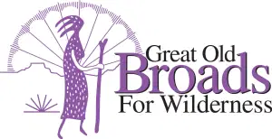

CASCADE VOLCANOES BROADBAND ZOOM MEETING

Tuesday, November 17, 2020

WELCOME and What’s New? Felice

6:45: “Underwater Seabed Mining: Why You Should Care” Lee First, Twin Harbors Waterkeeper

- ADVOCACY

  - Forests Issues Felice/Darlene
Elliott Research Forest;
Forest Carbon in Biden Climate Action Plan
Wildfire Response OR Legislature
  - LSRD Micky
  - Chehalis Basin Flood Control Laurie
  - Pumice Plain Susan/Micky
  - Get Out the Vote! Activity reports Jean

- EDUCATION

  - China Creek Restoration webinar November 18 @ 7pm Linda
  - JEDI Linda
  - Book Group? Ideas? Anyone?
  - Forest educational projects Micky

- STEWARDSHIP

  - Klickitat Forest Stewardship Micky

- FUN

A. Climate Change Trivia Night December 15 Laurie/Jean
B. Kayaking on the Chehalis w/Lee First Laurie
C. Bad Ass Broad Award Laurie
V. Other

A. COVID Form update on google doc Laurie

Next Meeting: Dec 15 6:30 Don’t miss our Climate Change Trivia Night!
With PRIZES!!!!!!!!

