SRCA Retreat April 6-8, 2021

Michael Carroll (TWS) 30 X 30 Biden’s EO overview

goal: to stave off climate changeel

foundation: 2016 EO Wilson Half Earth
We campaign for Nature – science advances refined idea –Global Deal for Nature. Knit together land conservation and climate concerns.
Enrique Salas –The nature of nature

why elevate nature and species crisis within the climate crisis 2.9 billions birds lost since 1970; only 12% of lands in US protected; ~16% in Colorado. Rate of protection decreased dramatically since the 1980s

directs land management agencies to work locally to advance 30 X 30/

protection: any area protected in its original condiditon where extractive acivies are limited.
includes municiple parks, open space to wilderness. Concern in EO can’t get to 30 x30 if only federal lands

5 principles:
- support locally led conservation solutions
- work toward more equitable and inclusive approach to conservation
- support private land conservation
- be guided by science
- honor sovereign nations and Indigenous knowledge.

Beau K CoCO state level
favorable trifecta –window of opportunity
we can define success
funding for conservation at state level
- new state parks and staffing
- wildlife corridors
- transportation

recent CO stimulus bill passed $20 million into state parks system; will also see federal stimulus money. Look at sustainable state conservation fund especially for new state parks.
The Nature Gap – Center for American Progress

CPW engaged in preparing state conservation plan release 2023 through 1. regional planning Outdoor Regional Partnerships 2. statewide convening Outdoor Partnership – opportunity for 30 x 30 to be embedded in this plan.

Vera & Lauren: Species

30 x30 on way to half!! biodiversity.
Protection = natural functions with binding enduring conservation protection

GAP 1, 2, 3, 4 USGS 1& 2 are protected (wilderness, W & S, national monuments – legal protection;) 3& 4 not protected

*********************************

Wednesday Marta Darby attorney at Earth Justice

https://mappingforej.berkeley.edu/

Jane Pargiter at EcoFlight
contact at Ute Mtn Ute John Trocheck Executive Director

outdoor equity fund for youth and families Gabriel Otero latino conservation week.

Next 100 Coalition
Green Latinos

Wildlife corridors Paige RMW

priority report
https://www.codot.gov/programs/research/pdfs/2019/WSWPS

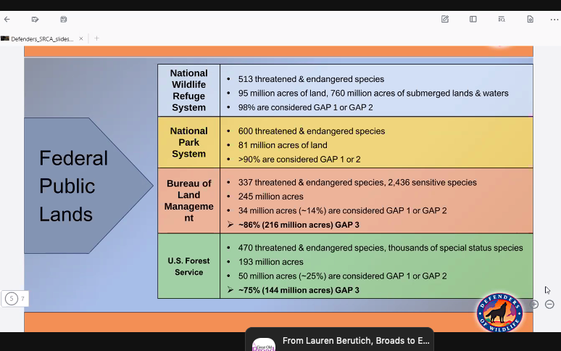

private lands are more biodiverse

28% of state of CO = gap 3 USFS and BLM

Katie Mehan staff attorney at
climate focused EO
executive dept and agencies review past harmful Eos; Polis strong EO
language revising emission standards – vehicles and methane.
protection of landscapes BENM, GSENM
morotorium on O & G and ANWR
true cost of carbon
commitment to just transition; climate conservation corp

environmental justice; what we know about disproportionate impact. First of it’s kind white house en 30% to frontline communities

pause on O & G until overview of fed managed resources and not tribal lands. April 15 DOI what to incorporate into review. substantive changes and process. What should be addressed and how.

net zero
decoupleing state
fiscal reform fair return to tax payers
account for public health and human impact.

Chris Canaly email 4.5.21

multiple EOs
video on utube re: Chris French 23 minutes
listen to recording of chris

Scott Braden CO Wildlands Project (with Juli slivka)
BLM wildliands – roadless, wsa and recovering
8,3 million acres in CO and only 8% protected; last significant was Browns Canyon, but congress last = 2009 DENM; half millon acres of WSA currently that if added to national wilderness system would achieve 15% of BLM protected.

BLM lands did not become eligilble for wilderness until 197?6 whereas Wilderness act 1964
Admin: EOs will be significant and leadership Deb Haaland/Nina Culvert
restore BLM ability to designate new WSAs (most in CO date back to 1980s) state of UT settlement put limit on new WSAs; RMPs, Grand Junction RMP Remand Scott just mentioned: https://wildernessworkshop.org/federal-judge-voids-western-colorado-fracking-plan-requires-new-analysis-of-climate-harm/
statewide wildlife corridors conservation

Legislative: DeGette’s bill… asking Hick to be a champion

Questions
Mark: redefine “community support” not soley county commissioners

Breakout Share:
can now have overlapping designations within BLM lands

