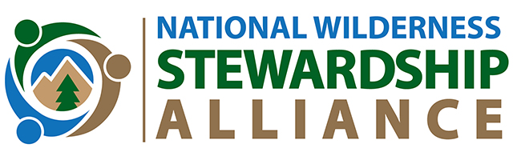
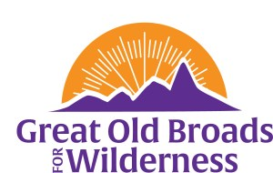
Cascade Volcanoes Great Old Broads for Wilderness
FOR IMMEDIATE RELEASE

Volunteers Monitor Indian Heaven Wilderness for Solitude in Southwest Washington
Contact Laurie Kerr at lauriekerr@pacifier.com
The Cascade Volcanoes Chapter of the Great Old Broads for Wilderness has completed the monitoring season by partnering with the U.S. Forest Service to monitor trails in Indian Heaven Wilderness for solitude. Great Old Broads for Wilderness is a women-led national grassroots organization that engages and inspires activism to preserve and protect wilderness and wild lands. Our vision is to ensure that wild public lands are treasured for their intrinsic values and protected for current and future generations.
Solitude is one of the characteristics of wilderness which Broads” volunteers measured during the June – October 2023 season in the Indian Heaven Wilderness located in the Gifford Pinchot National Forest in Washington State.
16 volunteers completed 25 four-hour shifts measuring solitude during the June – October 2023 season. Over 500 hours of volunteer time were logged, and 20 trips were fulfilled for the project. The trails ranged in length from 6 miles to more than 10 miles per zone. The data collected included the number of visitors noted in the wilderness during daylight hours. This data was submitted to the U.S. Forest Service and will assist the Mt. Adams Ranger District in increasing scores for solitude quality of wilderness character. Volunteers were rewarded with tshirts and dinners at local food establishments. The project was funded by the National Wilderness Stewardship Alliance.

Cascade Volcanoes Broads volunteers are grateful for the support of the National Wilderness Stewardship Alliance. The volunteers will continue their work during the summer and fall season 2024 in Indian Heaven Wilderness to support the hard work of the men and women in the U.S. Forest Service.

