COLUMBIA BASIN SPRING FIELD TRIP!

April 17 - 19, 2024
5602 W 30th Ave, Kennewick, Wa 99338
5 bedrooms, 7 beds, 2.5 baths

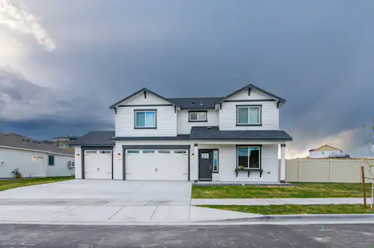

Wednesday, April 17 (Afternoon)

Hike in White Bluffs-North 7 miles RT
Directions:
From the Tri Cities, drive north on Highway 240 for 29 miles to a junction and stay straight to Highway 24. Cross the Vernita Bridge and stay on Highway 24 for 19 miles, then turn right (south) onto a gravel, signed road for the wildlife refuge. Continue for 4 miles, then take a right and drive downhill a 1.3 miles to a small parking area near the boat launch.
The parking area and trailhead are not marked but they're easy to see on the north (right) side of the road after dropping down the bluff. The trail starts next to a single fence post.
White Bluffs - North — Washington Trails Association (wta.org)
Sacagawea Heritage Trail bike/hike: This family-friendly paved path follows along the Columbia River at the confluence of the Yakima River. Some of the trail shares the road with vehicles, so using reflective materials, lights, or flagging is recommended for safety.
Accessibility: There are 4 designated accessible spaces in the paved parking lot off of Columbia Park Trail at the south end of the trail. All of them are van-accessible with striped access aisles. The trail surface is paved asphalt and smooth. It is typically at least 8 feet wide. There is a painted dividing line along some of the trail which reduces the width.
The majority of the trail is estimated to be in the mostly gentle (5% or less) grade category. This trail will likely be navigable for most wheelchairs/mobility equipment or stroller users.
https://www.alltrails.com/trail/us/washington/sacajewea-heritage-trail
Bike trail map of Tri Cities: 2020-Bike-Map-FINAL-DRAFT.pdf (biketricities.org)
6:00 pm Dinner (On your own)

Thursday, April 18
7:00 Breakfast
8:30 - 12:30 Tour of Manhattan Project B Reactor (20000 Logston Blvd, Richland, Wa)
Some of us have made reservations to tour the Hanford Project B nuclear reactor on April 17 or 18. Reservations can be made on this website:
Manhattan Project B Reactor Tours
1:00 Lunch on your own
2:00 Wanapum Heritage Center (Wanapum Heritage Center 29086 Wa 24) 45 min drive open Thurs 8:30 - 4:30

The Heritage Center is intended to protect preserve and perpetuate the culture traditions and identity of the Wanapum of Priest Rapids. It is located along the banks of the Columbia River, near Priest Rapids Dam, on the ancestral grounds of the Wanapum. The 50,000 sq ft facility houses a 10,000 sq ft permanent exhibit space, a 2,000 sq ft temporary rotating exhibit space, a climate controlled repository and collection facility, a library, staff offices and open space for large group activities conferences, demonstrations, training and living culture program activities.
Permanent Exhibit highlights include:
- interactive monitors
- 45-seat theatre
- Wanapum history film "Life as a Wanapum"
- dioramas and life-size tule mat lodge
- audio interviews with Wanapum about gathering, fishing hunting, trading and healing

Free admission

Friday, April 19

Sacagawea State Park, 2503 Sacajawea Park Rd, Pasco, 99301
Palouse Tribe Cultural Gathering–

Hosted by Giving Voice: Khimstonik
9:00 am - 2:00 pm Native American arts, crafts, songs, foods and more! Honor the shared hereditary responsibilities through remembrance and a living culture. Free admission but Discover Pass required for parking.
Broads are a community partner, and will have a table along with other supporters.

2:00 pm Farewell and safe travels!

List of Resources:

Why this is a pivotal moment for Hanford’s nuclear waste cleanup | The Seattle Times

Destroying and restoring or destruction and restoration- Challenges in the Columbia River basin.
Atomic Days: The Untold Story of the Most Toxic Place in America by Joshua Frank
“Apocalypse Factory: Plutonium and the Making of the Atomic Age” by Steve Olson about Hanford, its history and the use of the bomb.

